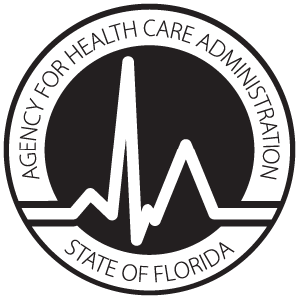

**Adult Day Care Center**

**OPERATOR IDENTIFICATION STATEMENT**

**AUTHORITY:** Pursuant to Section 408.806, Florida Statutes (F.S.) and 59A-35, Florida Administrative Code (F.A.C.) it is necessary to provide the Agency for Health Care Administration with the following information about the operator of an Adult Day Care Center. Your social security number will be used to secure the proper identification of the person listed on this document for licensure, criminal background checks, and the indexing of controlling interests.

|  |  |  |  |  |  |  |  |  |
| --- | --- | --- | --- | --- | --- | --- | --- | --- |
| **Adult Day Care Center Information** | | | | | | | | |
| Name of Adult Day Care Center: | | | | | **AHCA License #:** | | | |
| Street Address of Center: | | | | | | City: | | |
| Telephone Number: | | | Zip Code: | | | County: | | State: |
| **Center Operator Personal Information** | | | | | | | | |
| Center Operator Full Name | | | | Date of Birth: | | Social Security Number: | | |
| Street Address: | | | | Zip Code: | | City: | | |
| County: | State: | Email Address: | | | | | Effective Date of Appointment: | |

**NOTE: Pursuant to section 408.809 F.S., all center operators are subject to Level 2 background screening. Please review the information available at:** [**http://ahca.myflorida.com/MCHQ/Central_Services/Background_Screening/**](http://ahca.myflorida.com/MCHQ/Central_Services/Background_Screening/)

Please PRINT Name of Licensee or Authorized Representative

Signature of Licensee or Authorized Representative Title Date

**Send completed forms to: Agency for Health Care Administration, Assisted Living Unit, 2727 Mahan Drive, Mail Stop 30, Tallahassee, FL 32308 *or* email completed forms to:** [**assistedliving@ahca.myflorida.com**](mailto:assistedliving@ahca.myflorida.com)**.**

**Questions?**

Review the information available at <http://ahca.myflorida.com/>

or contact the Assisted Living Unit at:

Phone: (850) 412-4304

Email: [**assistedliving@ahca.myflorida.com**](mailto:assistedliving@ahca.myflorida.com)