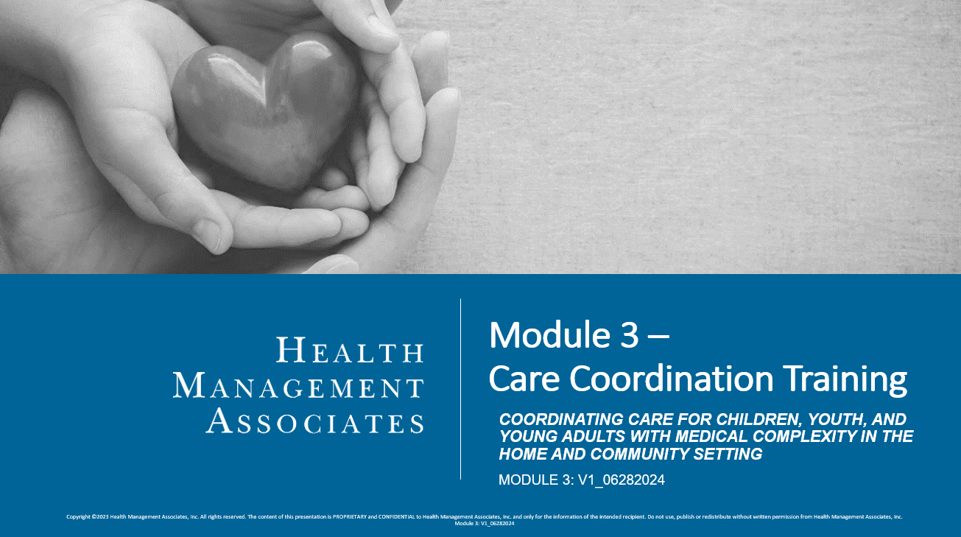
Assessment
- Match each description with the appropriate domain.
  - Screening, Identification, and Assessment. Description #:____
  - Shared Plan of Care. Description #:____
  - Team-Based Communication. Description #:____
  - Child and Family Empowerment and Skills Development. Description #:____
  - Care Coordination Workforce. Description #:____
  - Care Transitions. Description #:____

- Provides the foundation for effective, high-quality care coordination. Assessment is a continuous process that reflects ongoing conversations with CYSHCN and families about their needs, preferences, and priorities.
- Refers to the transfer of care between and within medical, behavioral health, social service, education, and justice systems.
- Communication between members of the care team is timely, efficient, respectful, and culturally sensitive.
- Care Coordination includes education, coaching, and training for CYSHCN, families, and care teams. This includes providing resources and advocating for and with CYSHCN and their families.
- Well trained and prepared to serve CYSHCN and their families. All care team members have opportunities to gain the knowledge needed to perform their roles effectively.
- Provides a roadmap and an accountability system for integrating care based on family needs and priorities identified in the assessment and is used in coordinating a child’s care.

- Fill in the blank: The life course perspective or life course theory (LCT) is a multidisciplinary approach to __________________________________________, which incorporates both life span and life stage concepts that determine the health trajectory.
  - Learning
  - Achieving developmental milestones
  - Care planning
  - Understanding the mental, physical, and social health of individuals

- A whole person health approach for CYSHCN and their families is an important aspect of achieving the goal that CYSHCN enjoy a full life from childhood through adulthood and thrive in a system that supports their families and their social, health, and emotional needs, ensuring their dignity, autonomy, independence, and active participation in their communities.
  - True
  - False

- What are strategies to improve access to PDN services. Select all that apply.
  - Offer coaching and education to families to help them improve their communication skills with home health agencies and nurses.
  - Connect families to family advocacy and peer organizations that have lived experiences navigating home health agencies and working with nurses in their homes.
  - Consider alternatives to offer the parent(s)/guardian(s) (e.g., exploring PPECs or new home health agencies).
  - Encourage families to move to better coverage areas.

- What are three ways that care coordinators continuously seek to identify the changing and new needs of enrollees and their families? Select three options
  - Sending handouts in the mail
  - Frequent interactions
  - Assessments
  - Care Plans

Key

  - 1
  - 6
  - 3
  - 4
  - 5
  - 2
- d
- a
- a, b, c
- b, c, d

