Facilitation Guide for Care Coordination Training: Module 3 – Care Coordination Training: Coordinating Care for Children, Youth, and Young Adults with Medical Complexity in the Home and Community Setting
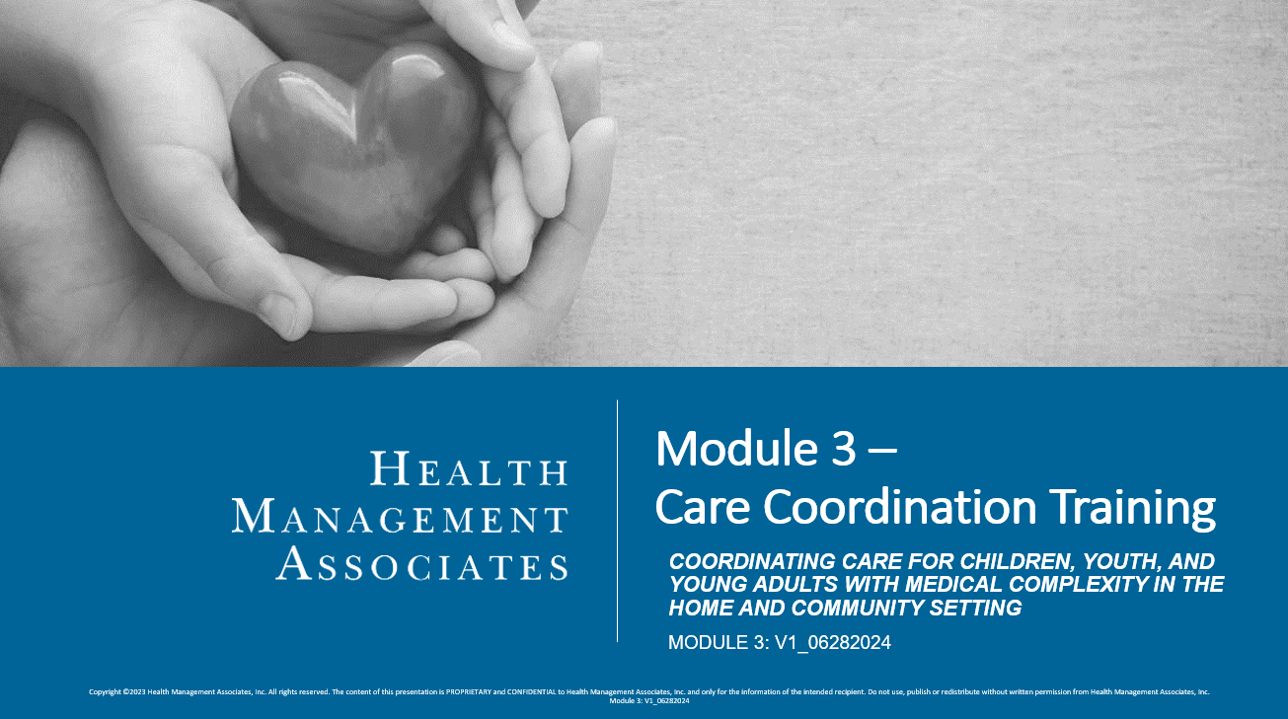

Instructions:
- Read through the PowerPoint slides and the facilitation guide before giving the training. There are 50 slides, and 6 sections.
- This Module may take 120 minutes to complete and is recommended to be delivered “classroom style” with a teacher, in a group setting (in-person or via a virtual platform), and with opportunities for group interactions, activities, and discussions.
- Depending on your audience and delivery modality, you may break this content into several learning sessions, if needed and when appropriate.
- You must cover all sections within this training. You should not change the content in the slides; however, you should enhance this content by providing your care coordinators with additional materials as applicable, including your health plan’s contractual obligations, policies, procedures, tools, templates, etc. Other supplemental materials such as videos, handouts, reading materials, etc. can also be used to further enhance discussions and learning in the classroom setting and beyond.
- There are discussion prompts given throughout the facilitation guide. Prompts should be used, however, you have flexibility in deciding the best way to engage your audience, given your audience size, training modality, and available time.
  - To encourage timeliness and effective discussion, consider providing participants with parameters for answering discussion questions (e.g., 1-2 minutes to respond).
  - Remember to create a supportive and positive environment for learning. Value the experiences and perspectives that care coordinators will bring to this training. Encourage positive and generative discussions that facilitate knowledge transfer that they can apply to their day-to-day interactions with the children and families they serve.
- In addition to the knowledge checks embedded in the module, additional formative assessment methods can also be used and tailored to your audience’s needs. One source for ideas can be found here (see chapter 5 specifically): https://www.education.nh.gov/sites/g/files/ehbemt326/files/inline-documents/makeitfast.pdf
- After participants complete this training, provide them with the accompanying assessment and course evaluation.

Facilitation Guide:
- All components and sections must be covered during your training, unless otherwise indicated.
Section Title |  | Discussion Topics/Questions for Engagement
Introduction and Background, Slides 1-5 |  | Optional: Once you have reached slide 5, pause and ask participants if they have any questions on the Introduction and Background Slides.
National Care Coordination Standards for CYSHCN, Slides 6-18 |  | ☐National Care Coordination Standards for CYSHCN: Domains and Key Components (Slides 8-14)  - Prompt participants to share their experiences with the group regarding each domain. Which do they find most important? Where have they had success in effectively implementing key components? What do they find challenging?  - If time permits, consider spending time within the actual standards document (pdf linked on slide 8).  - Supplement this section with contractual obligations/requirements, internal policies and procedures, plan-specific tools, templates, processes, etc.  ☐“Meet Bree” Case Study (Slides 15-16)  - Read Bree’s scenario on slide 15.  - Read through the questions on slide 16. Ask participants to share answers with the group and ask if they have other questions that come to mind. Talk as a group about approaches to take with this family and where you see some big challenges occurring.  - Best practice: review questions and reflect beforehand, noting prompts and answers that will help generate discussion with the group.  - Ask follow-up questions, such as “why,” or, “do you have any past experiences that came to mind when listening to these questions?”  ☐Knowledge Check (Slides 17-18)  - Depending on group size and time, these can be completed independently or discussed as a group. Remember you can expand this section with other interactive activities to assess knowledge gain and to facilitate collaborative dialogue among participants.  - The second question will have multiple answers, so prepare beforehand to understand additional answers the participants may offer.
Coordinating Holistic and Integrated Care, Slides 19-28 |  | ☐Definitions (Slides 20-23)  - After presenting the definitions, pause and ask participants, “Is there anything you would add to these definitions? If so, why?”  - Ask if there are other considerations as to why these approaches are important to CYSHCN and their families that you would add/expand on?  - Ask participants to share their experiences, successes, and challenges around incorporating these concepts into the way they conduct their care coordination activities.  ☐Coordinating Holistic and Integrated Care: Application for Care Coordinators (Slide 24)  - Ask participants if there is anything they would add to this list.  - Supplement this section and the conversation with any organization-specific policies, procedures, and best practices that are relevant.  ☐Coordinating Holistic and Integrated Care: Integrated Care Needs and Care Planning (Slide 25)  - Prompt participants with the scenarios on the right slide of the slide. Explore options and ideas that would promote integrated and holistic care in these instances.  ☐Coordinating Holistic and Integrated Care: Continuity of Care and Care Transitions (Slide 26)  - Spend time as a group working through possible steps and considerations to ensure continuity of care in each of the transitions described on slide 26. Supplement the conversation with additional materials to help care coordinators understand any specific contractual requirements or internal policies, procedures, tools, etc.  ☐Knowledge Check (Slides 27-28)  - Depending on group size and time, these can be completed independently or discussed as a group. Remember you can expand this section with other interactive activities to assess knowledge gain and to facilitate collaborative dialogue among participants.  - The third question will have multiple answers, so prepare beforehand to understand additional answers the participants may offer.
Ongoing Services and Supports for Children Receiving PDN and Their Families, Slides 29-40 |  | ☐Ongoing Services and Supports for Children Receiving PDN and Their Families (Slides 30-33)  - Review available services with the group (the services are the same as those introduced in Module 2.) Spend time going through the column on the far right. Ask participants to share their experiences, insights, and questions related to ensuring that these services are available and provided, as medically necessary, to their members.  - Supplement this section and the conversation with plan-specific contractual requirements and internal policies, procedures, tools, and resources.  ☐Missed PDN Hours (Slides 34-35)  - After reviewing these slides, ensure ample time for the group to ask questions and share their own experiences, successes, and challenges. As applicable, review internal policies and procedures.  - When reviewing slide 35, supplement with any plan-specific procedures or best practices you expect nurses to utilize.  ☐New Service Needs (Slide 36)  - Supplement the conversation with any plan-specific contract requirements, policies, procedures, processes, and tools that help care coordinators identify new needs and ensure connections are made.  ☐“Meet Alex” Case Study (Slides 37-38)  - Read Alex’s scenario on slide 37.  - Read through the questions on slide 38. Ask participants to share answers with the group and ask if they have other questions that come to mind. Talk as a group about approaches to take with this family and where you see some big challenges occurring.  - Best practice: review questions and reflect beforehand, noting prompts and answers that will help generate discussion with the group.  - Ask follow up questions, such as “why,” or, “do you have any past experiences that came to mind when listening to these questions?”  ☐Knowledge Check (Slides 39-40)  - Depending on group size and time, these can be completed independently or discussed as a group. Remember you can expand this section with other interactive activities to assess knowledge gain and to facilitate collaborative dialogue among participants.  - The third question will have multiple answers, so prepare beforehand to understand additional answers the participants may offer.
Putting it all in Practice – A Case Study, Slides 41-46 |  | ☐Case Study: The Suarez Family (Slide 42)  - Ask participants to recall The Suarez Family from Modules 1 and 2. Elaborate that this is a continuation of their story. Read through the green box on the right hand side of the slide. Consider pausing and asking participants if they have any questions about the Suarez Family. Have the group recall and recap what was done with this this family in Module 1 to promote cultural competency, family-centered, trauma-informed care, and family engagement, and in Module 2 to develop the transition plan goals for the family.  ☐Case Study: The Suarez Family (Slide 43)  - Advance to slide 43 and ask participants to read through the questions and write down their thoughts. After several minutes, initiate discussion by order of topic, asking participants to briefly share their thoughts:  - Identifying the most important things first  - Transitional care needs  - Ongoing needs  - Ask the group to share their ideas and experiences related to each of the questions on this slide. How will they update the care plan? What will they be anticipating after transition, that is most important? What will they do when issues arise?  ☐Case Study: The Suarez Family – Example Care Coordination Check List (Slide 44)  - Give participants a few moments to read through the example care coordination check list. Ask participants their thoughts on the example list, if they would add or takeaway anything, or if they have any questions about each step outlined (e.g., post-discharge and ongoing.)  - Supplement this section and the conversation with any plan-specific timeframes or steps outlined in contractual requirements, policies, and procedures. Highlight any resources or tools you will require your care coordinators to utilize.  ☐Case Study: The Suarez Family – Example Care Plan (Slides 45-46)  - If needed, revisit the care plan from module 2 (if they created their own, have them bring it back out).  - Once you have revisited the original care plan, review slide 45 for additional care planning needs and updates.  - As a group, develop a new care plan for this family. If time permits, consider brainstorming care planning goals and activities at intervals in the future (e.g., post discharge for three months, six months, one year, and at age 21, incorporating the topics presented in module 3.)  ☐Case Study: The Suarez Family (Slide 47)  - Give participants a few moments to read through and hypothesize what actions they would take or how they might answer the questions presented on the slide. Open discussion and allow participants to freely answer whatever question feels most important to them.
Conclusion, Slides 48-50 |  | ☐Ask the group to reflect on the various topics covered in this module. What was something new they learned? What is something they will be eager to incorporate into their care coordination activities? What do they want more information on?  ☐Provide participants with the assessment and course evaluation for completion and collect them at the end.

