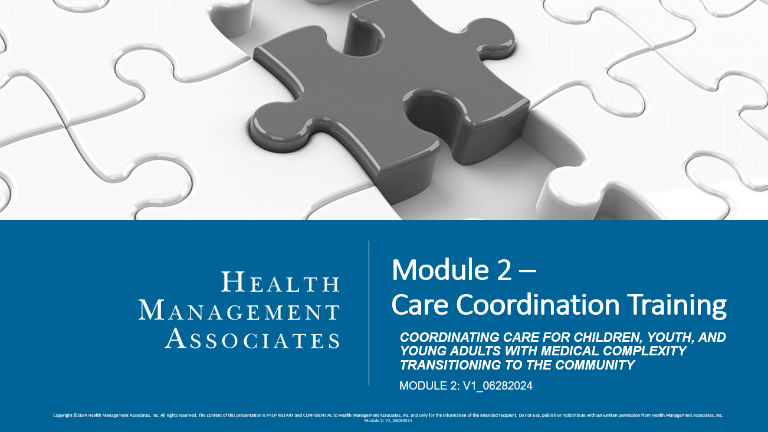
Assessment
- Which of the following are goals of effective transition planning? Select all that apply.
  - To identify issues needing early intervention
  - To prevent unnecessary hospitalization and readmissions
  - To support person and family preferences and choices
  - To avoid duplication of processes and efforts
  - To prevent medical errors

- Match the following descriptions to the appropriate transition planning best practice:
  - Proactive processes. Description #:____
  - Promote family engagement. Description #:____
  - Readiness assessments. Description #:____
  - Discharge follow up. Description #:____
  - Check-ins. Description #:____
  - Reconvening the Multidisciplinary Team (MDT). Description #:____

- Establish frequent check-ins with family to identify and address issues early as they emerge. Consider alternative ways for the family to connect with you, as needed and according to their needs and preferences.
- Transition Planning begins before admission.
- A Home Evaluation; family/caregiver skills checklist; services and supports identified- including providers, equipment, and supplies; and Emergency and Safety Plans
- Conduct an MDT to comprehensively assess any ongoing and new needs.
- Coordinate with families to follow up post-discharge to ensure that parents feel knowledgeable and comfortable, that environment and equipment are suitable for their child as planned, no gaps in care are occurring, and that no new needs have been discovered not previously planned for.
- Transition Planning is family-centered and trauma-informed, delivered in a culturally competent way that promotes and values family engagement.

- The complexity of an individual’s condition does not mean they can’t be cared for at home if that is their parent/guardian’s preference.
  - True
  - False

- Match the descriptions to the appropriate service.
  - Private Duty Nursing (PDN). Description #:____
  - Prescribed Pediatric Extended Care (PPEC). Description #:____
  - Medical Foster Care. Description #:____
  - Family-to-Family Home Visits. Description #:____
  - Family-to-Family Peer Support. Description #:____
  - iBudget Waiver. Description #:____

- One-on-one, medically necessary nursing care from a skilled nurse. These services are available in the home and the child may be eligible to receive up to 24 hours a day
- An opportunity to connect the family to another family that has received PDN for a child with Complex Medical Needs. Interactions may be one-on-one, or with a group of families. Interactions may be in-person, virtual, or by phone.
- Designed to promote and maintain the health of individuals with developmental disabilities and to provide medically necessary supports and services to prevent placement in a nursing home. Services are for eligible children 3 or older with a developmental disability.
Services include:
- Home Modifications: Adaptations to home for accessibility, such as ramps and door-widening
- Vehicle Modifications: Adaptations to the vehicle for accessibility, including portable ramps
- Consumable Medical Supplies: such as diapers, wipes, and pads
- Residential Habilitation: Enables eligible children to live in licensed group homes up to 24 hours a day with nursing services and medical supervision
- An opportunity for families to visit other family homes where children are receiving PDN in the home. During the visit, they will observe PDN provided to the child and have an opportunity to ask questions. Visits can be in-person or virtual and the child’s care coordinator can accompany the family.
- Centers for children through age 20. Provides skilled nursing supervision, medical services, nursing services, personal care, psychosocial services, respiratory therapy services, and developmental therapies in a non-residential setting. Transportation is provided in addition to caregiver training. Available for up to 12 hours a day
- A program for children through age 20. Provides temporary placement for 24-hour care in a licensed foster home with specially trained foster parents. Participation in this program is time-limited unless the child is in state custody

- What are some tools that Care Coordinators can use to help families identify additional services and community supports?
  - 2-1-1
  - Hope Florida Pathways to Prosperity
  - Florida Alliance of Information and Referral Services
  - Legal Aid
  - All of the above
  - None of the above

- Which of the following should you do as a Care Coordinator?
  - To avoid confusion, only use one online tool as a resource for available services for children transitioning to the community from a nursing facility.
  - Use printed copies of lists of PDN providers as your resource, since provider availability never changes anyway.
  - Center conversations with families around your own personal preferences of providers.
  - Discuss and review available services and supports during the individual’s Transition Planning Process, at a minimum, and document on the Transition Plan.

- What are some ways that a Care Coordinator can be an effective liaison? Select all that apply.
  - Use effective communication techniques
  - Demand to be the leader of all meetings and conversations
  - Promote trust
  - Focus on building relationships

- As a liaison, what are important components that you should leverage to support effective coordination and communication?
  - Contracts and phone trees
  - Multidisciplinary teams and clear policies, procedures, and protocols
  - Telephone and email
  - Paper charts and checklists

- Match the descriptions to the common barriers to community integration:
  - Attitudes. Description #:____
  - Communication. Description #:____
  - Physical. Description #:____
  - Policy. Description #:____
  - Programmatic. Description #:____
  - Social. Description #:____
  - Transportation. Description #:____
- Lack of understanding about available resources and eligibility criteria
- Health-related social needs such as housing, food, and education; family dynamics, composition, and needs
- Lack of accessible information in one’s preferred language and learning style; not considering health literacy needs
- Lack of access to reliable transportation; lack of access to a transportation modality that can accommodate special needs or equipment
- Stereotypes and stigma; assumptions about needs and available resources
- Lack of inclusive design to accommodate one’s special needs (e.g., inconvenient scheduling, lack of accessible equipment)
- Spaces that are not accommodating one’s mobility needs

- As a Care Coordinator, which techniques will you use when assessing for and removing barriers to transitioning children, youth, and young adults with medical complexity to a community setting? Select all that apply.
  - Email communication only to ensure everything is documented.
  - Family-centered and family-informed planning.
  - Family education and support for all aspects of the transition and discharge plans.
  - Accountability for ensuring all loops are “closed” during pre-transition, transition, and post-transition.

Key:
- a, b, c, d, e

  - 2
  - 6
  - 3
  - 5
  - 1
  - 4
- a

  - 1
  - 5
  - 6
  - 4
  - 2
  - 3
- e
- d
- a, c, d
- b

  - 5
  - 3
  - 7
  - 1
  - 6
  - 2
  - 4
- b, c, d

