Facilitation Guide for Care Coordination Training: Module 2 – Care Coordination Training: Coordinating Care for Children, Youth, and Young Adults with Medical Complexity Transitioning to the Community
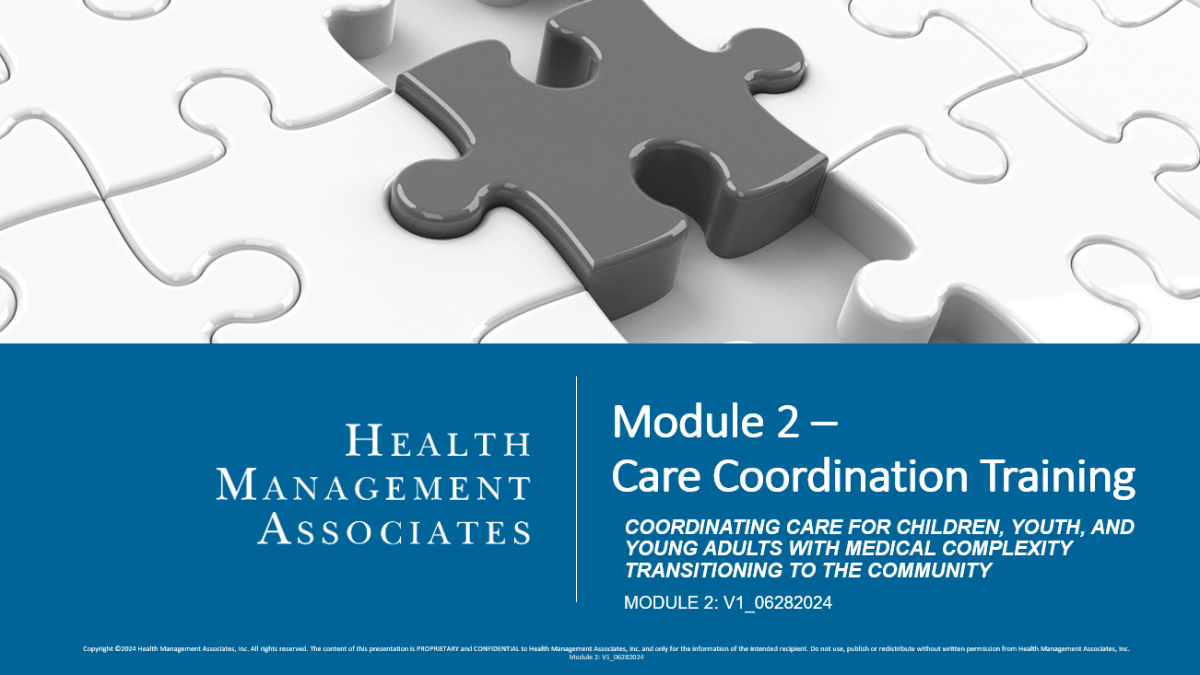

Instructions:
- Read through the PowerPoint slides and the facilitation guide before giving the training. There are 60 slides, and 7 sections.
- This Module may take 120 minutes to complete and is recommended to be delivered “classroom style” with a teacher, in a group setting (in-person or via a virtual platform), and with opportunities for group interactions, activities, and discussions.
- Depending on your audience and delivery modality, you may break this content into several learning sessions, if needed and when appropriate.
- You must cover all sections within this training. You should not change the content in the slides; however, you should enhance this content by providing your care coordinators with additional materials as applicable, including your health plan’s contractual obligations, policies, procedures, tools, templates, etc. Other supplemental materials such as videos, handouts, reading materials, etc. can also be used to further enhance discussions and learning in the classroom setting and beyond.
- There are discussion prompts given throughout the facilitation guide. Prompts should be used, however, you have flexibility in deciding the best way to engage your audience, given your audience size, training modality, and available time.
  - To encourage timeliness and effective discussion, consider providing participants with parameters for answering discussion questions (e.g., 1-2 minutes to respond).
  - Remember to create a supportive and positive environment for learning. Value the experiences and perspectives that care coordinators will bring to this training. Encourage positive and generative discussions that facilitate knowledge transfer that they can apply to their day-to-day interactions with the children and families they serve.
- In addition to the knowledge checks embedded in the module, additional formative assessment methods can also be used and tailored to your audience’s needs. One source for ideas can be found here (see chapter 5 specifically): https://www.education.nh.gov/sites/g/files/ehbemt326/files/inline-documents/makeitfast.pdf
- After participants complete this training, provide them with the accompanying assessment and course evaluation.

Facilitation Guide:
- All components and sections must be covered during your training, unless otherwise indicated.
Section Title |  | Discussion Topics/Questions for Engagement
Introduction and Background, Slides 1-5 |  | Optional: Once you have reached slide 5, pause and ask participants if they have any questions on the Introduction and Background Slides.
Effective Transition Planning, Slides 6-12 |  | Optional video to share with participants: "Virtual Home Visit for a Child With Medical Complexity: Post-Discharge Considerations" (youtube.com). Consider encouraging participants to share their reflections on the video, and discuss considerations, challenges, and best practices that are health plan and Florida specific.  ☐Effective Transition Planning: Best Practices (Slides 7-10)  - After reading through slides 8-10, ask participants, “Are there any other transition planning best practices you would add to these lists?”  - Ask participants to share their experiences and best practices they use in their daily care coordination activities.  - When reviewing the example readiness assessment on slide 9, ask the group if they know of other key components that they would be assessing for a child’s readiness to be discharged home.  - Supplement this section and the conversation with contractual requirements and internal policies and procedures that provide time frames, procedural steps, etc. that a care coordinator must follow.  ☐Knowledge Check (Slides 11-12)  - Depending on group size and time, these can be completed independently or discussed as a group. Remember you can expand this section with other interactive activities to assess knowledge gain and to facilitate collaborative dialogue among participants.  - These questions will have multiple answers, so prepare beforehand to understand additional answers the participants may offer.
Available Services and Supports, Slides 13-29 |  | ☐Available Services and Supports (Slides 14-20)  - Pause on each slide for questions. Supplement this section with contractual requirements and internal policies and procedures that will help care coordinators know how to connect members to each service described.  - As available, facilitators should obtain additional information (e.g., available volunteers, forms, processes, or policies) for services like the family-to-family home visits and the family-to-family peer support.  ☐iBudget Waiver and Medical Foster Care Additional Information (Slides 21-22)  - Spend time with the group on these slides to make sure they understand these services, how to access them, and how to find out more information.  - Supplement this section with any additional resources, such as forms, policies, or procedures that may be relevant.  ☐Available Services and Supports (Slides 23-24)  - Ask the group if there are other resources they use.  - Supplement this section and the conversation with any additional resources or internal policies and procedures that they should use/follow.  - Supplement this section and the conversation with additional local resources available (churches, non-profits, etc).  ☐Application for Care Coordinators (Slide 25)  - Ask the audience, “Is there anything additional you would add to this?”  ☐“Meet Will” Case Study (Slides 26-27)  - Read Will’s scenario on slide 26.  - Read through the questions on slide 27. Ask participants to share answers with the group and ask if they have other questions that come to mind. Talk as a group about approaches to take with this family and where you see some big challenges occurring.  - Best practice: review questions and reflect beforehand, noting prompts and answers that will help generate discussion with the group.  - Ask follow-up questions, such as “why,” or, “do you have any past experiences that came to mind when listening to these questions?”  ☐Knowledge Check (Slides 28-29)  - Depending on group size and time, these can be completed independently or discussed as a group. Remember you can expand this section with other interactive activities to assess knowledge gain and to facilitate collaborative dialogue among participants.  - These questions will have multiple answers, so prepare beforehand to understand additional answers the participants may offer.
Your Liaising Role as a Care Coordinator in the Transition Planning Process, Slides 30-38 |  | ☐Role Definitions (Slide 31)  - After presenting the definitions, pause and ask participants, “Is there anything you would add to these definitions? If so, why?”  - Prompt participants to share any experiences, successes, or challenges as being in the facilitator and liaison roles.  ☐Promoting Effective Coordination and Communication and Your Liaising Role as a Care Coordinator (Slides 32-33)  - Ask the group, “Do you have any experiences when utilizing a team-based approach in your role as a care coordinator? If so, how was that successful for you? Is there anything you would add to this list of considerations?  - Supplement this section and the conversation with any internal policies or procedures that that they should follow. As applicable, take time to review any related health plan-specific materials. (This includes taking time to review this PT, or any subsequent updates: PT 2023 -14 and its Attachment A).  - Supplement this section with State and AHCA-specific protocols for conducting the transition planning meetings and the transition plan. Review the current template with the participants.  ☐Your Liaising Role as a Care Coordinator: Application (Slide 34)  - Ask participants, “Which one of these feels most important in your role as care coordinator? Why do you feel that way?” Could also consider asking participants if there is anything else they would add to this list.  ☐“Meet Ben” Case Study (Slides 35-36)  - Read Ben’s scenario on slide 35.  - Read through the questions on slide 36. Ask participants to share answers with the group and ask if they have other questions that come to mind. Talk as a group about approaches to take with this family and where you see some big challenges occurring.  - Best practice: review questions and reflect beforehand, noting prompts and answers that will help generate discussion with the group.  - Ask follow up questions, such as “why,” or, “do you have any past experiences that came to mind when listening to these questions?”  ☐Knowledge Check (Slides 37-38)  - Depending on group size and time, these can be completed independently or discussed as a group. Remember you can expand this section with other interactive activities to assess knowledge gain and to facilitate collaborative dialogue among participants.  - These questions will have multiple answers, so prepare beforehand to understand additional answers the participants may offer.
Removing Barriers to Community Integration, Slides 39-46 |  | ☐Removing Barriers to Community Integration: Assessing for Barriers (Slide 40)  - After presenting the different barriers, consider asking participants if there is anything they would add to this list.  - Prompt them to share their own experiences with these common barriers. What about differences in actual and perceived barriers? For each of these barriers, what are potential enablers?  ☐Removing Barriers to Community Integration (Slide 41)  - Encourage group discussion by asking these questions:  - Are there any other barriers for children with medical complexity as they plan to transition home that you would add to this list?  - Do you have examples or experiences that have been successful when you have engaged in addressing barriers to transition?  ☐Removing Barriers to Community Integration: Application (Slide 42)  - Ask participants, “Which one of these strategies feels most important in your role as care coordinator? Why do you feel that way?” Also ask participants if there is anything else they would add to this list.  - Supplement this section and the conversation with any organization-specific policies, procedures, and best practices that are relevant.  ☐“Meet Amy” Case Study (Slides 43-44)  - Read Amy’s scenario on slide 43.  - Read through the questions on slide 44. Ask participants to share answers with the group and ask if they have other questions that come to mind. Talk as a group about approaches to take with this family and where you see some big challenges occurring.  - Best practice: review questions and reflect beforehand, noting prompts and answers that will help generate discussion with the group.  - Ask follow up questions, such as “why,” or, “do you have any past experiences that came to mind when listening to these questions?”  ☐Knowledge Check (Slides 45-46)  - Depending on group size and time, these can be completed independently or discussed as a group. Remember you can expand this section with other interactive activities to assess knowledge gain and to facilitate collaborative dialogue among participants.  - These questions will have multiple answers, so prepare beforehand to understand additional answers the participants may offer.
Putting it all in Practice – A Case Study, Slides 47-57 |  | ☐Case Study: The Suarez Family (Slide 48)  - Ask participants if they remember the Suarez Family from Module 1 and elaborate that this is a continuation of their story. Read through the green box on the right hand side of the slide. Consider pausing and asking participants if they have any questions about the Suarez Family. Have the group recall and recap what was done with this this family in Module 1 to promote cultural competency, family-centered, trauma-informed care, and family engagement.  ☐Case Study: The Suarez Family (Slide 49)  - Advance to slide 49 and ask participants to read through the questions and write down their thoughts. After several minutes, initiate discussion by order of topic, asking participants to briefly share their thoughts:  - Identifying the most important things first  - Effective Transition Planning  - Services and Supports for the Child and Family  - Your Liaising Role as a Care Coordinator in the Transition Planning Process  - Removing Barriers to Community Integration  ☐Case Study: The Suarez Family – Example Care Plan (Slides 50-52)  - Give participants a few moments to read through the transition plan goals that have been developed for the Suarez Family. Ask participants their thoughts on the example care plan, if they would add or takeaway anything, or if they have any questions about the example care plan (e.g., caregiver training, family supports, mental/behavioral health needs.)  - Supplement this section by having participants develop their own care plan for the Suarez family. For additional practice, additional scenarios can be presented for additional care planning practice.  - As and additional activity, consider a mock transition planning meeting exercise and completing a transition plan.  ☐Case Study: The Suarez Family (Slide 53)  - Give participants a few moments to read through and hypothesize what actions they would take or how they might answer the questions presented on the slide. Open discussion and allow participants to freely answer whatever question feels most important to them.  ☐Case Study: The Suarez Family (Slide 54)  - Advance to slide 54. Build off of the previous slides and care planning work to carry the scenario forward to when the daughter is ready to go home.  ☐Case Study: The Suarez Family (Slide 55)  - Advance to slide 55 and ask participants to read through the questions and write down their thoughts. After several minutes, initiate discussion by order of topic, asking participants to briefly share their thoughts:  - Identifying the most important things first  - Transitional care needs  - Ongoing needs  ☐Case Study: The Suarez Family – Example Care Coordination Check List (Slide 56)  - Give participants a few moments to read through the example care coordination check list. Ask participants their thoughts on the example list, if they would add or takeaway anything, or if they have any questions about each step outlined (e.g., just prior to discharge, day of discharge, etc.)  - Supplement this section and the conversation with any plan-specific timeframes or steps outlined in contractual requirements, policies, and procedures. Highlight any resources or tools you will require your care coordinators to utilize.  ☐Case Study: The Suarez Family (Slide 57)  - Give participants a few moments to read through and hypothesize what actions they would take or how they might answer the questions presented on the slide. Open discussion and allow participants to freely answer whatever question feels most important to them.
Conclusion, Slides 58-60 |  | ☐Ask the group to reflect on the various topics covered in this module. What was something new they learned? What is something they will be eager to incorporate into their care coordination activities? What do they want more information on?  ☐Provide participants with the assessment and course evaluation for completion and collect them at the end.

