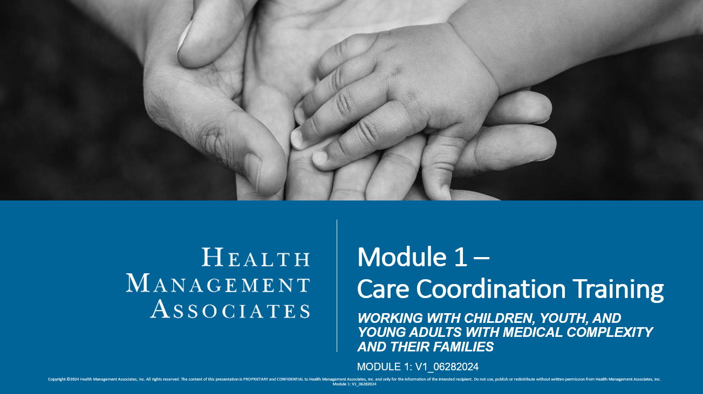
Assessment
- Match the following descriptions to the appropriate cultural competency pillar:
  - Awareness. Description #:____
  - Attitude. Description #:____
  - Knowledge. Description #:____
  - Skills. Description #:____

- Exploring your values, beliefs, and personal cultural norms; Understanding your openness to differing views and opinions; Being curious about culture and lives of others, being nonjudgmental about differences
- Examining your own understanding and beliefs; Reflecting on your actions, reactions, and interpretations; Recognizing opportunities for personal development
- Integrating one’s awareness, attitude, and knowledge into repeated practice and interactions with the people they serve
- Seeking out information and developing a deeper understanding of how culture impacts and influences health and healthcare-related interactions

- Which of the following should be used in your care coordination activities? Select all that apply.
  - Practice patience and listening.
  - Center the enrollee’s and family’s needs and preferences in goals and interventions.
  - Establish your values in conversations so that the enrollee and family can align with your views.
  - Recognize and accept cultural differences and norms when assessing and care planning.
  - Offer and use interpreters, visual aids, or other alternatives to meet the enrollee’s and family’s communication preferences.

- When meeting a new enrollee and their family, what is one way that you can practice cultural competency?
  - Wait until the end of the conversation to ask about their language preferences.
  - Avoid asking questions about their religious beliefs.
  - Skip assessment questions that you think they may not understand.
  - Spend time with the family asking about their culture, values, and beliefs that might influence the way they prefer to interact with the healthcare system.

- Family-Centered Care is a way of providing services that assures the health and well-being of children and their families through respectful family/professional partnerships. It honors the strengths, cultures, traditions, and expertise that families and professionals bring to this relationship.
  - True
  - False

- Family-centered care:
  - Starts with trust, emphasizes autonomy, and focuses on self-efficacy and choice
  - Recognizes the importance of community-based services
  - Promotes an individual and developmental approach
  - All of the above
  - None of the above

- Match the following descriptions to the appropriate trauma-informed care principle:
  - Safety. Description #:____
  - Trustworthiness and Transparency. Description #:____
  - Peer Support. Description #:____
  - Collaboration and Mutuality. Description #:____
  - Empowerment, Voice, and Choice. Description #:____
  - Cultural, Historical, and Gender Issues. Description #:____

- Recognize strengths and believe in resiliency and healing. Offer choices and options, focus on skill building, and promote accountability and responsibility
- Come to interactions with humility and responsiveness to past and current biases and stereotypes, including recognizing historical traumas. It is critical to respect autonomy, culture, and beliefs.
- Establish an equal partnership and support shared decision-making. This can include identifying and shifting actual or perceived power differences.
- Leverage and incorporate persons with lived experiences.
- Build and maintain trust within the conversation and relationship. Some ways to do this are to use non-judgmental language, show empathy and compassion, and follow through on commitments.
- Create a safe space, during interactions and within your organization. It is also crucial to establish clear boundaries.

- What are the Four “Rs” in the Trauma-informed framework?
  - Realize, Recognize, Respond, Resist Retraumatization
  - Respect, Rest, Realize, Recognize
  - Realize, Recognize, Remind, Repeat
  - Report, Remind, Realize, Recognize

- Family engagement means:
  - Goals are given to the family by the care coordinator.
  - That the family is only a part of the care team after care planning is complete and health decisions have been made.
  - That the family is an active and equal partner in their child’s care.
  - Only the family can call their child’s primary care provider.

- Which of the following should be used in your care coordination activities? Select all that apply.
  - Focusing on health literacy
  - Promoting informed decision-making
  - Building self-management and self-efficacy skills
  - Waiting to make goals until after a member is home

- What is one way that you can promote family engagement in your care coordination activities?
  - Involve the family in the care planning process, co-creating goals that are based on the family’s preferences and values, promoting their personal and family strengths.
  - Give them handouts when they ask questions.
  - Don’t share the care plan with them to prevent them from becoming overwhelmed.
  - Remind them about their child’s limitations each time they ask about available services and supports.

Key:

  - 2
  - 1
  - 4
  - 3

- a, b, d, e
- d
- b
- d

  - 6
  - 5
  - 4
  - 3
  - 1
  - 2
- a
- c
- a, b, c
- a

