Facilitation Guide for Care Coordination Training: Module 1 – Care Coordination Training: Working with Children, Youth, and Young Adults with Medical Complexity and Their Families
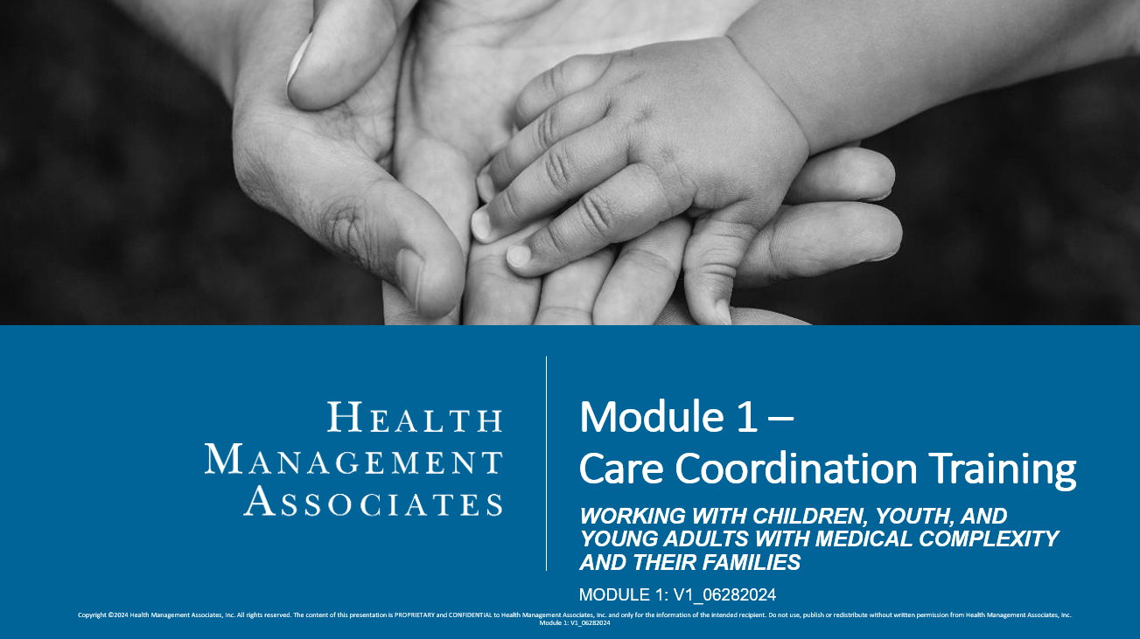

Instructions:
- Read through the PowerPoint slides and the facilitation guide before giving the training. There are 53 slides, and 7 sections.
- This Module may take 120 minutes to complete and is recommended to be delivered “classroom style” with a teacher, in a group setting (in-person or via a virtual platform), and with opportunities for group interactions, activities, and discussions.
- Depending on your audience and delivery modality, you may break this content into several learning sessions, if needed and when appropriate.
- You must cover all sections within this training. You should not change the content in the slides; however, you should enhance this content by providing your care coordinators with additional materials as applicable, including your health plan’s contractual obligations, policies, procedures, tools, templates, etc. Other supplemental materials such as videos, handouts, reading materials, etc. can also be used to further enhance discussions and learning in the classroom setting and beyond.
- There are discussion prompts given throughout the facilitation guide. Prompts should be used, however, you have flexibility in deciding the best way to engage your audience, given your audience size, training modality, and available time.
  - To encourage timeliness and effective discussion, consider providing participants with parameters for answering discussion questions (e.g., 1-2 minutes to respond).
  - Remember to create a supportive and positive environment for learning. Value the experiences and perspectives that care coordinators will bring to this training. Encourage positive and generative discussions that facilitate knowledge transfer that they can apply to their day-to-day interactions with the children and families they serve.
- In addition to the knowledge checks embedded in the module, additional formative assessment methods can also be used and tailored to your audience’s needs. One source for ideas can be found here (see chapter 5 specifically): https://www.education.nh.gov/sites/g/files/ehbemt326/files/inline-documents/makeitfast.pdf
- After participants complete this training, provide them with the accompanying assessment and course evaluation.
- Health Plans should consider other trainings available to care coordinators and determine whether care coordinators should complete general training in the areas of cultural competency, person- and/or family-centered care, and trauma informed care, before or consecutively with these trainings.

Facilitation Guide:
- All components and sections must be covered during your training, unless otherwise indicated.
Section Title |  | Discussion Topics/Questions for Engagement
Introduction and Background, Slides 1-6 |  | Optional: Once you have reached slide 6, pause and ask participants if they have any questions on the Introduction and Background Slides.  - Idea for discussion/point to make: The concepts that make up the framework on slide 6 are all critical components, that when used together, promote trust and help care coordinators work effectively with members and their families.
Cultural Competency, Slides 7-17 |  | Optional video to share with participants: Cultural Competence (youtube.com)  ☐Definitions (Slides 8-9)  - When covering the definitions portion (slides 8-9), pause and ask participants, “Is there anything you would add to these definitions? If so, why?”  ☐Cultural Competency Pillars and Essential Elements (Slides 10-11)  - For added context to the slide content, offer examples or hypothetical situations for the participants to reflect on.  - Prompt your participants to share experiences, insights, and perspectives.  - Idea for discussion/point to make: regarding the pillars on slide 10, to summarize, at the individual or personal level, to be culturally competent is to examine one’s own attitude and values, and the acquisition of the values, knowledge, skills, and attributes that will allow an individual to work appropriately in cross cultural situations.  - Idea for discussion/point to make: regarding the essential elements on slide 11, these elements should be adopted at the Theses essential elements should be adopted at the induvial and organizational level  - Value Diversity: recognizing and respecting that diversity enriches one’s experiences  - Adapt to Diversity: Understanding your member’s and their family’s community, context, values, and beliefs allows you to provide individualized support to best meet their personal health goals.  - Acquire Cultural Knowledge: always seek to learn more and understand others’ cultures, values, and beliefs.  - Self-Assessment: introspection and reflection should occur often. Where can you improve? Where are you doing well and really connecting with the member and their family?  - Manage the Dynamics of Differences: Differences are a natural part of interactions. Learning personal strategies that help keep conversations positive and focused on the member/family goals and preferences will help you arrive at creative and co-developed solutions when issues arise.  ☐Application for Care Coordinators (Slide 12)  - Ask the audience, “Is there anything additional you would add to this?”  - You can also expand on practical application and implications for care coordination practice. One source is: https://thinkculturalhealth.hhs.gov/education/behavioral-health  ☐“Meet Michael” Case Study (Slides 13-14)  - Read Michael’s scenario on slide 13.  - Read through the questions on slide 14. Ask participants to share answers with the group and ask if they have other questions that come to mind? Reflect as a group on the cultural norms that may influence Michael’s family. Talk as a group about listening and patient/family centered goal setting. Talk about the four pillars in the context of this scenario.  - Best practice: review questions and reflect beforehand, noting prompts and answers that will help generate discussion with the group.  - Ask follow up questions, such as “why,” or, “do you have any past experiences that came to mind when reviewing these questions?”  ☐Knowledge Check (Slides 15-16)  - Depending on group size and time, these can be completed independently or discussed as a group. Remember you can expand this section with other interactive activities to assess knowledge gain and to facilitate collaborative dialogue among participants.
Family-Centered Care, Slides 17-27 |  | Optional video to share with participants: What is Family-Centered Practice? (youtube.com)  ☐Definitions (Slide 18)  - After presenting this definition, pause and ask participants, “Is there anything you would add to this definitions? If so, why?”  ☐Principles for Coordinating Care for CSYCHN (Slide 19)  - Ask the group if they have any personal examples they are willing to share based on of one of the principles shared (e.g., Do you have an example of a time where one of these principles supported your care coordination?)  - Idea for discussion/point to make: these principles are built on a foundation of dignity and respect. Trust is established and deepened using these principles.  - If time permits, supplement the conversation with a resource such as: https://www.ipfcc.org/bestpractices/sustainable-partnerships/background/pfcc-defined.html  ☐Key Considerations (Slide 20)  - Elaborate on how these things can be accomplished and prompt the audience to share their experiences, insights, and perspectives on techniques such as patient centered care planning, SMART goals, motivational interviewing, active listening, open and transparent communication, etc.  ☐Approach to the Planning Process (Slide 21)  - Ask participants if they have anything they would add to the approach.  ☐Freedom of Choice Forms (Slide 22)  - Review the information about Freedom of Choice Forms.  - Incorporate it back to being family-centered in the conversation.  - Refer to the policy transmittal links as needed, along with any updated guidance from AHCA. Spend time going through the most up-to-date forms.  - Incorporate any health plan specific policies and procedures into the conversation as needed.  ☐Application to Care Coordinators (Slide 23)  - Ask the audience, “Is there anything additional you would add to this?”  ☐“Meet Claire” Case Study (Slides 24-25)  - Read Claire’s scenario on slide 24.  - Read through the questions on slide 25. Ask participants to share answers with the group and ask if they have other questions that come to mind. Talk as a group about approaches to take with this family and where you see some big challenges occurring.  - Best practice: review questions and reflect beforehand, noting prompts and answers that will help generate discussion with the group.  - Prompt participants to talk about family customs around food, music, enjoyment, and roles of family members – how will this kind of information impact your approach to interacting with the family and coordinating care?  - Consider asking follow up questions, such as “why,” or, “do you have any past experiences that came to mind when listening to these questions?”  ☐Knowledge Check (Slides 26-27)  - Depending on group size and time, these can be completed independently or discussed as a group. Remember you can expand this section with other interactive activities to assess knowledge gain and to facilitate collaborative dialogue among participants.  - The second and third questions will have multiple answers, so prepare beforehand to understand additional answers the participants may offer.
Trauma-Informed Care (Slides 28-37) |  | Optional videos to share with participants:  What is Trauma-Informed Care? - YouTube  3 Principles of a Trauma-Informed Approach - YouTube  Optional, additional source for additional information: Trauma-Informed Care Implementation Resource Center: https://www.traumainformedcare.chcs.org/what-is-trauma-informed-care/  ☐Definitions (Slide 29-30)  - After presenting the definitions, pause on each slide and ask participants, “Is there anything you would add to these definitions? If so, why?”  - Idea for discussion/point to make: Some examples of potentially traumatic events for children with medical complexity include: traumatic separation and life-threatening illness.  ☐Trauma-Informed Care: Key Principles and Assumptions (Slide 31-32)  - Spend time as a group discussing what each of the trauma-informed “key” principles means to them (or pick a couple) and ask participants to share examples.  - Ideas for discussion/points to make:  - Safety – Create a safe space, during interactions and within your organization. It is also crucial to establish clear boundaries.  - Trustworthiness and Transparency – Build and maintain trust within the conversation and relationship. Some ways to do this are to use non-judgmental language, show empathy and compassion, and follow through on commitments.  - Peer Support – Leverage and incorporate persons with lived experiences  - Collaboration – Establish an equal partnership and support shared decision-making. This can include identifying and shifting actual or perceived power differences.  - Empowerment – Recognize strengths and believe in resiliency and healing. Offer choices and options, focus on skill building, and promote accountability and responsibility  - Cultural, Historical, and Gender Issues – Come to interactions with humility and responsiveness to past and current biases and stereotypes, including recognizing historical traumas. It is critical to respect autonomy, culture, and beliefs.  - After reviewing the four “Rs” framework, ask the group about a time when using the 4 Rs framework has helped them. Are there times that they haven’t used this framework? What happened?  - Ideas for discussion/points to make:  - Realize – Need to have an awareness and understanding that  - Trauma is pervasive – impacting many of us and in many different ways. It is part of the human experience.  - Trauma changes the physiology of the child - impacting the physical health, mental health, and social well-being of the child.  - Trauma can affect families, groups, communities, as well as individuals.  - Trauma is also relative and cumulative.  - Bottom line- Trauma is complex!  - APPROACH: ASSUME TRAUMA.  - Recognize  - Become familiar with the signs of trauma (this can be physical and behavioral).  - People behave in a way that is based on their experiences. A person’s behavior is a reflection of their desire/need to protect themselves.  - It takes that recognition to shift your perception and approach - Shift from “what’s wrong” to “what happened.”  - Respond  - Focus on resiliency and one’s strengths.  - Use evidence-based practices.  - Connect to evidence-based interventions.  - Resist Retraumatization  - Avoid behaviors or circumstances that may trigger memories or emotions.  - Consider practices that avoid having one re-live or re-tell their experience.  ☐Trauma-Informed Care: Application for Care Coordinators (Slide 33)  - Ask participants if there is anything they would add to this list to ensure successful application of trauma-informed care.  ☐“Meet Sophie” Case Study (Slides 34-35)  - Read Sophie’s scenario on slide 34.  - Read through the questions on slide 35. Ask participants to share answers with the group and ask if they have other questions that come to mind. Talk as a group about approaches to take with this family and where you see some big challenges occurring.  - Best practice: review questions and reflect beforehand, noting prompts and answers that will help generate discussion with the group.  - Consider asking follow up questions, such as “why,” or, “do you have any past experiences that came to mind when listening to these questions?”  ☐Knowledge Check (Slides 36-37)  - Depending on group size and time, these can be completed independently or discussed as a group. Remember you can expand this section with other interactive activities to assess knowledge gain and to facilitate collaborative dialogue among participants.  - The second and third questions will have multiple answers, so prepare beforehand to understand additional answers the participants may offer.
Family Engagement (Slides 38-46) |  | Optional video to share with participants: Patient Video: Nikki - YouTube  ☐Definitions (Slide 39)  - After presenting the definition, pause and ask participants, “Is there anything you would add to this definition? If so, why?”  ☐Family Engagement: A Call to Action (Slide 40)  - The Centers for Medicare & Medicaid Services (CMS) has published their Person & Family Engagement Strategy to:  - Enhance person and family engagement  - Establish definitions and consistency to help people [and families] engage in their healthcare  - Serve as a guide to support meaningful, intentional application of person and family engagement principles to all policies and programs addressing health and well-being  - Create a foundation for expanding awareness and enhance person and family engagement  - Review the call to action as a group and prompt participants to share their ideas and insights.  ☐Family Engagement: Family as an Active and Equal Partner (Slide 41)  - Engage the group in discussion. Consider asking some or all of these questions:  - What are your thoughts or reactions to having the family as an active and equal partner?  - Do you have examples or experiences that have been successful when you have engaged in family engagement-related activities?  - Which of the ideas presented on this slide do you regularly do now as a care coordinator? Which ones do you find challenging and why?  ☐Family Engagement: Application for Care Coordinators (Slide 42)  - Ask participants if there is anything they would add to this list.  ☐“Meet Kyle” Case Study (Slides 43-44)  - Read Kyle’s scenario on slide 43.  - Read through the questions on slide 44. Ask participants to share answers with the group and ask if they have other questions that come to mind. Talk as a group about approaches to take with this family and where you see some big challenges occurring.  - Best practice: review questions and reflect beforehand, noting prompts and answers that will help generate discussion with the group.  - Ask follow up questions, such as “why,” or, “do you have any past experiences that came to mind when listening to these questions?”  ☐Knowledge Check (Slides 45-46)  - Depending on group size and time, these can be completed independently or discussed as a group. Remember you can expand this section with other interactive activities to assess knowledge gain and to facilitate collaborative dialogue among participants.  - The second and third questions will have multiple answers, so prepare beforehand to understand additional answers the participants may offer.
Putting it all in Practice – A Case Study (Slides 47-50) |  | ☐Case Study: The Suarez Family (Slides 47-50)  - After reading through the case study (slide 48), ask participants to read through the questions (slide 49) and write down their thoughts. After several minutes, ask for discussion by order of topic, advancing to slide 50 while the group shares:  - Identifying the most important things first  - Cultural Competency  - Family-Centered Care  - Trauma-Informed Care  - Family Engagement
Conclusion (Slides 51-53) |  | ☐Ask the group to reflect on the various topics covered in this module. What was something new they learned? What is something they will be eager to incorporate into their care coordination activities? What do they want more information on?  ☐Provide participants with the assessment and course evaluation for completion and collect them at the end.

