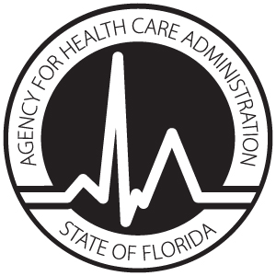
License Application
LEVEL I ADULT CARDIOVASCULAR SERVICES

AUTHORITY: Pursuant to subsections 408.0361(2) and (3), Florida Statutes, a provider of Level I adult cardiovascular services shall comply with rules adopted by the Agency that establish licensure standards that govern the provision of Level I adult cardiovascular services.

 | Provider Information
 | License #: | 12-month Reporting Period:
 | Name of Hospital: |  |  |  | Telephone Number:
 | Street Address:
 | City: |  | State: | Zip: |  | County:
Volume – Information in this section required for Initial Application Only – Not required for Renewal
Total Number of Adult Diagnostic Cardiac Catheterization Patients / Sessions:
Number of Inpatient Sessions: | Number of Outpatient Sessions:
OR
Total Number of Inpatient Discharges or Transfers with Principal Diagnosis of Ischemic Heart Disease
(ICD-10-CM codes I20 through I25):
Number of Inpatient Discharges: | Number of Inpatient Transfers:

This hospital confirms and will comply with the following:

- Initial Applicants only: The above named hospital volumes are true, accurate and complete.
- The above named hospital will fully comply, where applicable, with the guidelines of the American College of Cardiology/American Heart Association for staffing, physician training and experience, operating procedures, equipment and physical plant criteria to ensure quality patient care and safety, except where they are in conflict with Florida law.
- The above named hospital will fully comply with the physical plant requirements regarding cardiac catheterization laboratories and operating rooms found in section 419.2.1.2, Florida Building Code as applicable.
- The above named hospital has a formalized, written transfer agreement with a hospital that has a Level II adult cardiovascular program, including a written transport agreement(s) to ensure safe and efficient transfer of a patient within 60 minutes.
- The above named hospital will participate in the American College of Cardiology – National Cardiovascular Data Registry.
- The above named hospital has a formalized plan to provide services to Medicaid and charity care patients in need of Level I adult cardiovascular services.

____________________________________________________
Printed or typed name of Chief Executive Officer

Signature of Chief Executive Officer Date

Return completed AHCA forms 3130-8001 and 3130-8010 to:
Agency for Health Care Administration
Hospital and Outpatient Services Unit, MS # 31
2727 Mahan Drive
Tallahassee, FL 32308

