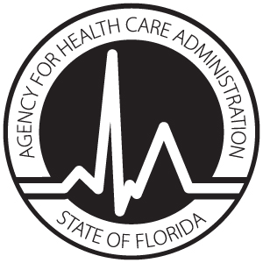
License Application
ADULT INPATIENT DIAGNOSTIC CARDIAC CATHETERIZATION SERVICES

AUTHORITY: Pursuant to subsection 408.0361(1), Florida Statutes, a provider of adult inpatient diagnostic cardiac catheterization services shall comply with rules adopted by the Agency that establish licensure standards that govern the provision of adult inpatient diagnostic cardiac catheterization services.

Provider Information
License #:

Name of Hospital: |  |  | Telephone Number:
Street Address:

City: | State: | Zip: |  | County:

This hospital confirms and will comply with the following:
- Comply with the most recent guidelines of the American College of Cardiology and American Heart Association Guidelines for Cardiac Catheterization and Cardiac Catheterization Laboratories.
- Comply with Section 419.2.1.2, Florida Building Code, which contains the physical plant requirements for adult inpatient diagnostic cardiac catheterization programs.
- Perform only adult inpatient diagnostic cardiac catheterization services and not provide therapeutic cardiac catheterization or any other cardiology services as a component of the adult inpatient diagnostic cardiac catheterization program.
- Maintain sufficient appropriate equipment and health care personnel to ensure quality and safety.
- Maintain appropriate times of operation and protocols to ensure availability and appropriate referrals in the event of emergencies.
- Demonstrate a plan to provide services to Medicaid and charity care patients.

____________________________________________________
Printed or typed name of Chief Executive Officer

Signature of Chief Executive Officer Date

Return completed AHCA forms 3130-8001 and 3130-5003 to:
Agency for Health Care Administration
Hospital and Outpatient Services Unit, MS # 31
2727 Mahan Drive
Tallahassee, FL 32308

