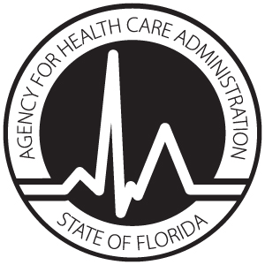
License Application
BURN UNIT SERVICES

AUTHORITY: Pursuant to subsection 408.0361(2), Florida Statutes, a provider of burn unit services shall comply with rules adopted by the Agency that establish licensure standards that govern the provision of burn unit services.

Provider Information
License #: | Date burn unit services begin:
Name of Hospital: |  |  |  | Telephone Number:
Street Address:

City: |  | State: | Zip: |  | County:

This hospital confirms and will comply with the requirements of 59A-3.246(5), Florida Administrative Code (F.A.C.), which governs operation of a burn unit. Licensure application is based on the status indicated below:

Burn Unit
The above named hospital meets the criteria specified in 59A-3.246(5), F.A.C., for a burn unit and I have attached documentation that indicates the burn unit in the above named hospital has been verified by the American Burn Association for adherence to “Guidelines for the Operation of Burn Units”.

OR

Provisional Burn Unit
The burn unit in the above named hospital is in partial compliance with “Guidelines for the Operation of Burn Units” but has not received initial verification from the American Burn Association. Burn unit services will begin/began on .

____________________________________________________
Printed or typed name of Chief Executive Officer

Signature of Chief Executive Officer Date

Return completed AHCA forms 3130-8001 and 3130-8012 to:

Agency for Health Care Administration
Hospital and Outpatient Services Unit, MS # 31
2727 Mahan Drive
Tallahassee, FL 32308

