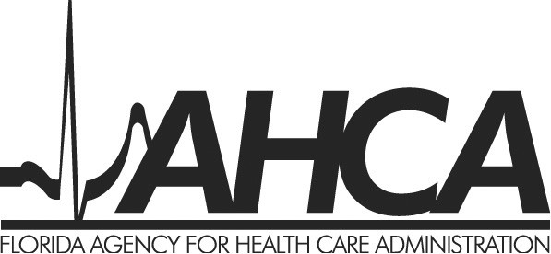
Adult Day Care Center
SPECIALTY LICENSE NOTIFICATION FRO

AUTHORITY: In accordance with section 429.918(3)(a), F.S., an adult day care center must notify the agency at least 30 days prior to initial licensure under s. 429.907, F.S. or, if already licensed, at least 6 months prior to the expiration of a license issued under s. 429.907, that the adult day care center is seeking designation as a Specialized Alzheimer’s Services Adult Day Care Center.
This form must be completed by the owner, operator, or corporate officer.

TO: Agency for Health Care Administration
Division of Health Quality Assurance
Bureau of Long Term Care Services
Assisted Living Unit
2727 Mahan Drive, MS # 30
Tallahassee, FL 32308-5403

Name of Adult Day Care Center:
Street Address: | City / State / Zip:
License Number(if applicable): | How Many Months to License Expiration?:
REGARDING:

NOTE: To obtain a specialty license to provide specialized Alzheimer’s services, an adult day care center must meet the requirements of Chapter 429, Part III and all other licensure requirements required by law. An adult day care center may not advertise that they hold this specialty license without first obtaining it from the Agency for Health Care Administration.

Signature of Owner/Corporate Officer/ Operator Printed Name of Owner/Corporate Officer/ Operator

