

AIRS User guide for managed care plans



Agency For Health Care Administration

Table of Contents

**AIRS System****2**

Advantages of AIRS2

Getting Started—Single Sign On and AIRS Registration3

The Basics of AIRS Navigation7

Creating An Adverse Incident Summary Report (MMA only, Specialty, and Dental Plans)11

**Creating A Critical Incident Summary Report (Comprehensive and LTC Plus Plans)19**

Creating An Individual Critical Incident Report27

What To Do If the Agency Returns Your Report For More Information40

**When the Agency Has Completed Its review42**

**How To Cancel A Report44**

**Troubleshooting**44

AHCA has developed an online system, the AHCA Incident Reporting System (AIRS system), for incident reporting. Facilities, such as hospitals and assisted living facilities have been using AIRS for incident reporting for several years. New modules for SMMC health plans to report individual critical incident reports and monthly adverse/critical incident summary reports have now been added to the AIRS system. Following implementation of these new modules, health plans will no longer submit the monthly adverse and critical incident summary report through the FTP site and LTC plans will no longer submit individual critical incident reports via encrypted email to their contract manager. Instead, the reports will be completed and submitted to the Agency utilizing AIRS.

**Advantages to AIRS**

1. Ease of use---on-line application versus Excel spreadsheet. Most fields utilize drop-down menus, radial buttons, or are pre-populated, based on your sign-on credentials.
2. Efficiency---no more FTP uploads or emailing reports between multiple users/reviewers
3. More Secure---no more emailing confidential information
4. Searchable database---all incident reports are maintained in a searchable database.
5. Administrative use---readily see critical incident trends

**What each managed care plan must do prior to implementation**

Each managed care plan needs to determine who needs access to AIRS. Only users that the Agency has granted access to AIRS will be able to utilize AIRS for reporting.

It is strongly recommended that MMA-only health plans, specialty health plans, and dental plans have at least two approved AIRS users for their health plan.

Health plans rendering long-term care (LTC) services need more AIRS users, as individual critical incidents must be reported to the Agency within 24-hours of the LTC plan being notified of the incident. It is strongly recommended that the LTC plans obtain AIRS access for all of their staff that have historically completed individual critical incident reports and monthly summary reports, such as case management supervisors, risk managers, plan contract managers, etc.

**Obtaining AIRS access-Single Sign On**

Users will need to create a Single Sign On (also known as the AHCA Portal) account before they can request access to AIRS.

**The link to the Portal is:** [**https://apps.ahca.myflorida.com/SingleSignOnPortal**](https://apps.ahca.myflorida.com/SingleSignOnPortal)**.** The Portal looks like the snapshot below. New users will complete their AIRS registration agreement by clicking on the New User Registration link at bottom of the webpage. Skip this step if you have already created an SSO account. Use your existing username and password to login.

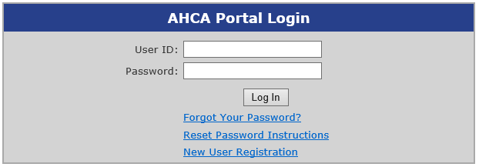

Follow the prompts until you reach the Account Registration screen.

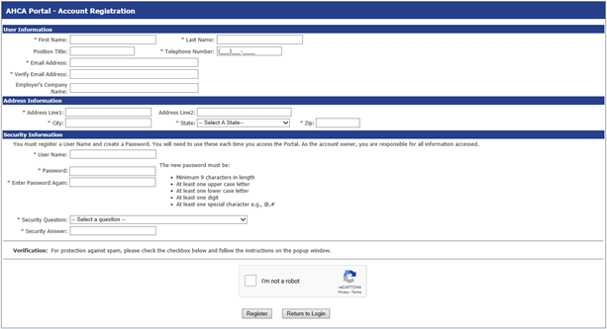

Fill out the required fields and click the Register button. NOTE: Be sure your email address is correct. This is the email account AIRS uses to send emails to you.

Click the Return to Login button.

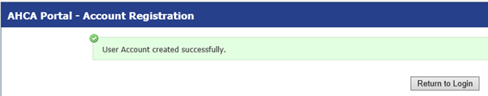

**Obtaining AIRS access-AIRS Registration**

Now you will need to request access to your specific health plan within AIRS. To begin, log into the AHCA portal (SSO) using your new username and password.

Choose AHCA Incident Reporting System from the list of programs and click the Request Program Access button.

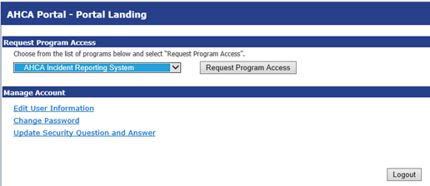

Choose Medicaid Managed Care Plan in Provider/Facility Category. See screenshot below.

Choose Medicaid Plan in Provider/Facility Type. See screenshot below.

Type the first few letters of your plan’s name in the Provider/Facility Name field. NOTE: The plan type (MMA, LTC, SPEC, or DENTAL) is displayed in the Provider/Facility Name field after the plan name and before the city. Be sure to choose the correct plan type. See screenshot below.

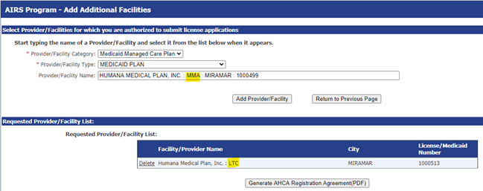

Click the Add Provider/Facility button.

The Provider/Facility Name field is cleared, and the plan name is added to the Requested Provider/Facility List.

Click the Generate AHCA Registration Agreement (PDF) button.

Click the link in the upper right hand corner of the screen to open a printable copy of the registration agreement.

Print and sign the registration agreement, have it signed by the plan administrator whose name appears on the user agreement, scan it, and email it the email address that appears on the user agreement for AHCA Central Intake.

The user agreement for new accounts must be received and approved by Agency staff before accessing the site. You will receive an email notification when access has been approved. Once access is granted, users may submit adverse and critical incident reports via the AIRS system.

Note: Each approved AIRS user needs to retain their username and password. The best way to do this is to retain a copy of your AIRS user agreement, which is generated at the conclusion of the registration process. Approved AIRS users must NOT share their log-in credentials with other managed care plan employees.

**If an AIRS user forgets their username**

Look for the copy of your User Registration Agreement. The User ID appears in the upper right side of the form. If you can’t find your User Agreement, call AHCA’s Central Services Department (850-412-3951) and they will attempt to verify your information before providing you with your User ID. If they are unable to verify your information, you will need to re-register and send in a new User Registration Agreement.

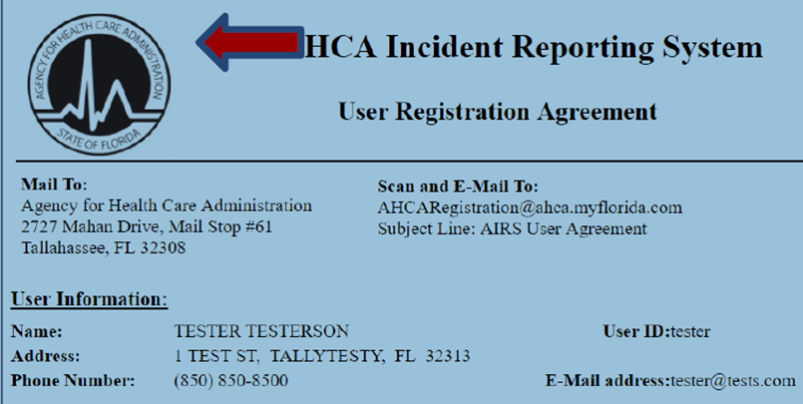

**If an AIRS user forgets their password**

AHCA does not have access to a User’s Password. You will need to click on “Forgot your Password?” and follow the directions. If you cannot answer your security question, you will NOT be able to recover the password for your account. You will need to re-register and send in a new User Registration Agreement.

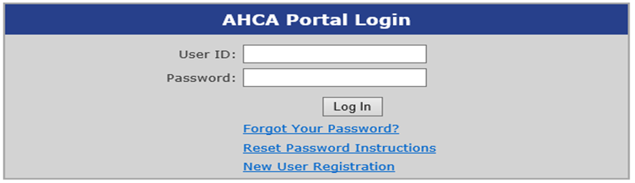

NOTE: All AIRS users authorized for the same health plan AND plan type component can see and work on the same reports. If one person at the health plan starts a report, another person at the health plan can add the attestation or submit the report. If one person at the health plan submits the report, either the same person OR a different person at the health plan can re-submit the report in response to a NEED INFO request.

**Getting Started in AIRS—The Basics**

After you log-in to the Single Sign On Portal, the AHCA Portal Landing will appear. Click on AHCA Incident Reporting System.

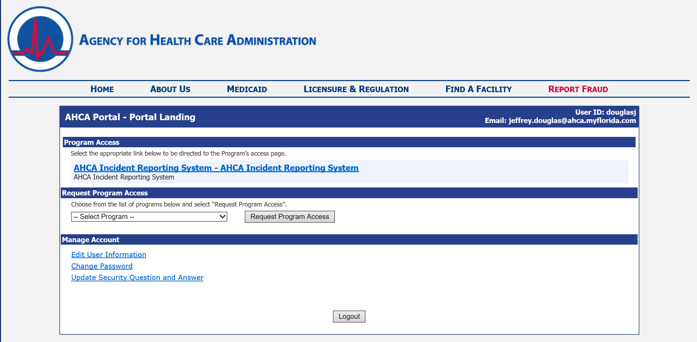

You will next see the AIRS Program-Tasks menu. Click on AIRS Reports.

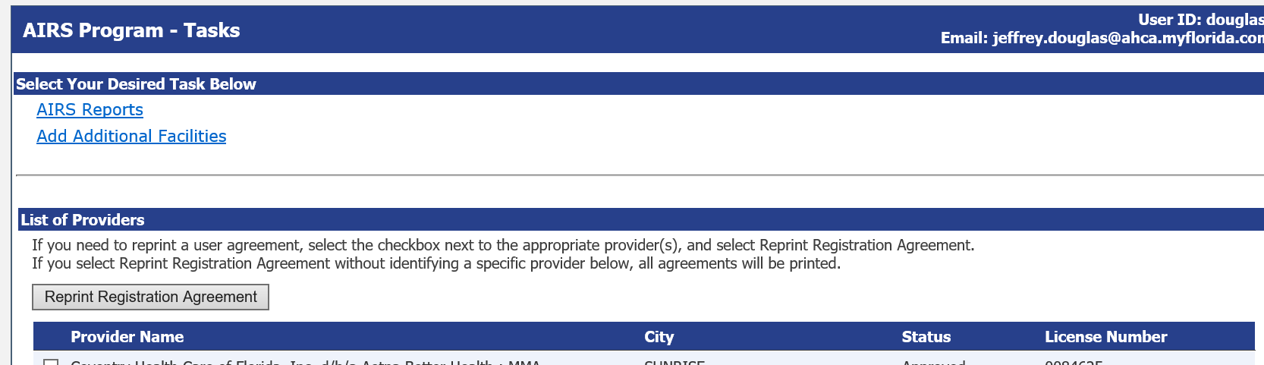

AIRS will open to your plan’s Dashboard. The Dashboard shows the status of all ACTIVE incident reports. The Dashboard’s toolbar also contains links for New Report, Search, and Helpful Links.



“New” is the link for creating a new report.

“Search” can be used to look up all the reports for your health plan or a specific report if you have the report number or other pertinent information regarding that report.

A “Helpful Links” tab has been added for your convenience. The tab contains useful information for filing your report, such as an on-line copy of this user guide. Click on the blue lettering to open the link.

The Dashboard shows the Current Status of an incident report. Once you have started a report, you may check on the Current Status by viewing your Dashboard. The Dashboard only shows Open Reports. Once the Agency has closed a report, that report will not appear on your Dashboard.

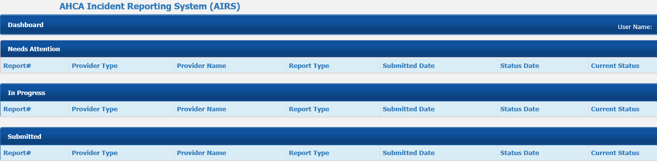

The Dashboard reflects three different report statuses.

Needs Attention---Once the report has been reviewed by AHCA Quality Bureau staff, the report will appear on your Dashboard under the “Needs Attention”section if additional information is needed related to the report. The current status will appear as “Need Info”.

The report sender will receive an email from the AIRS system alerting him/her that a report was returned for information. AIRS will continue to generate daily email reminders until the health plan resubmits the report back to the Agency.



In Progress---If your report is “New” or “Draft”, it will appear under the “In Progress” section until you have submitted your report. In other words, a report appearing on your Dashboard in the In Progress section has NOT been submitted to the Agency. The current status will appear as “New”. It is important to note that the In Progress section does not show reports that are due, but not yet started by the managed care plan.



Submitted---Reports your plan have submitted to the Agency will appear here and will show a current status of “under review”.



The screenshot below shows a dashboard with reports in all three categories, Needs Attention, In Progress, and Submitted.

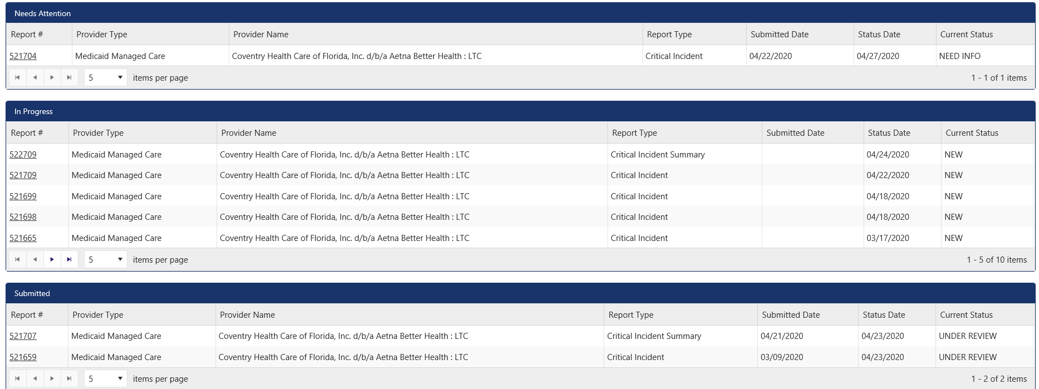

See page 42 for instructions on how to Cancel a report if it was created in error. Only reports that have not been submitted can be cancelled. If a report created in error was submitted, then you’ll need to contact your contract manager to ask that the report status be set to NEED INFO so the report can be withdrawn.

**How to Create the Monthly Adverse and Critical Incident report for MMA-only, Specialty Plans and Dental Plans**

All managed care plan adverse and incident reporting begins the same way. From the Dashboard, click on “New”.



**AIRS will bring up a Create New Report screen.**

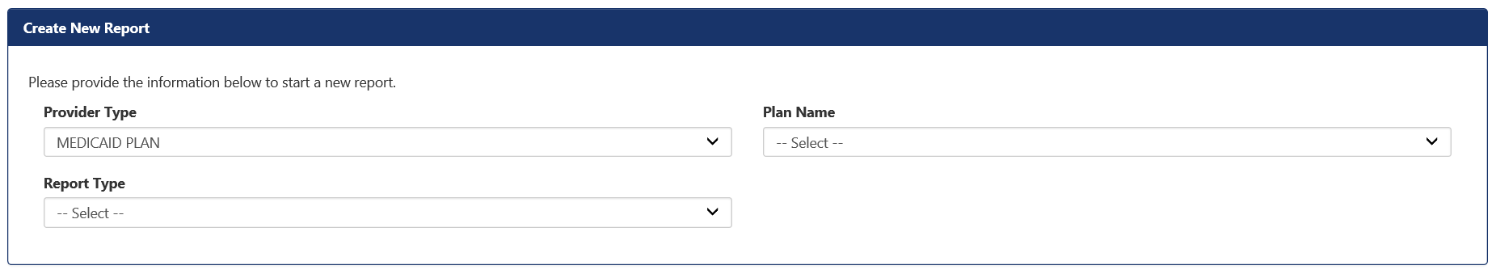

Provider Type on the Create New Report Screen defaults to Medicaid Plan. This is correct. Do not change this Provider Type.

Select your plan name from the drop down menu.

Since MMA-only health plans, specialty plans, and dental plans are only required to submit the monthly adverse incident summary report, the report type will default to this report type when the chosen health plan if an MMA-only, specialty, or dental plan.

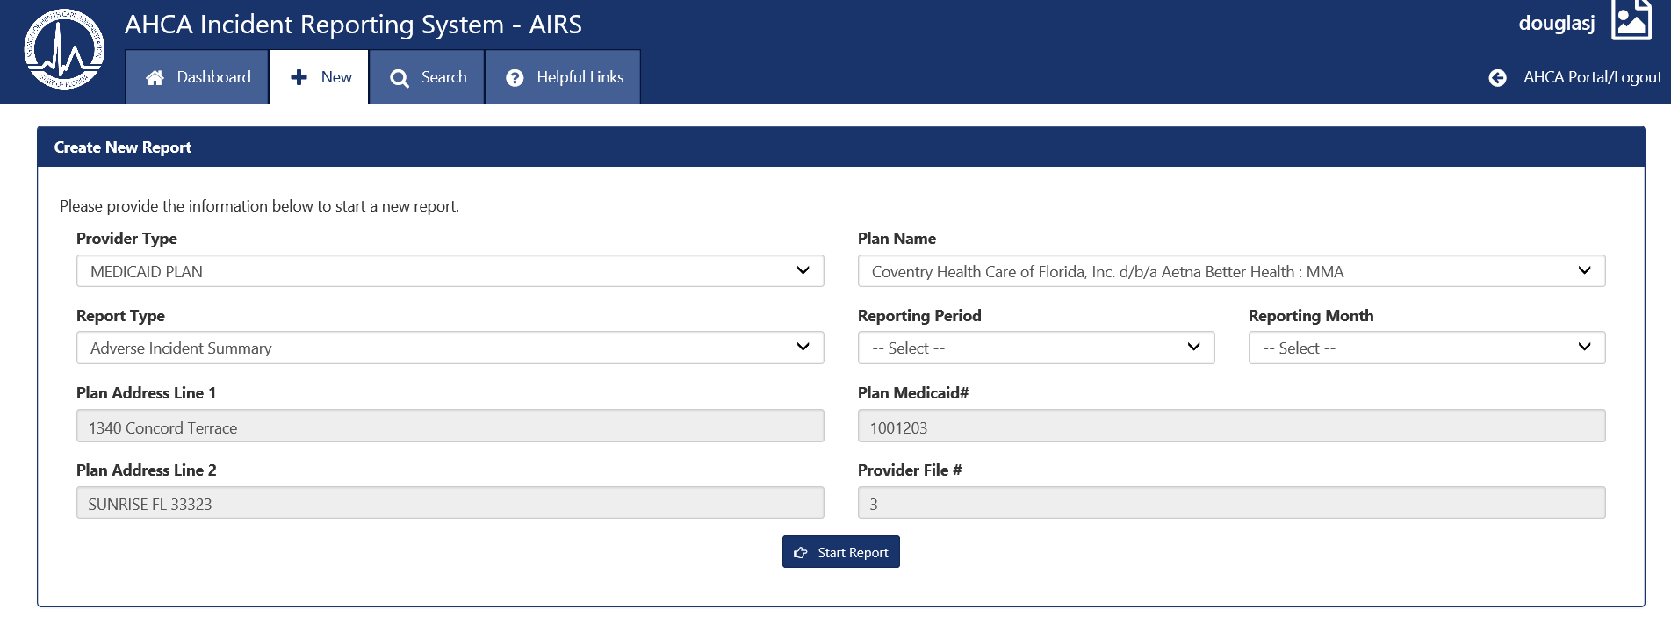

You will next select the reporting period (year) and reporting month from the drop down menu.

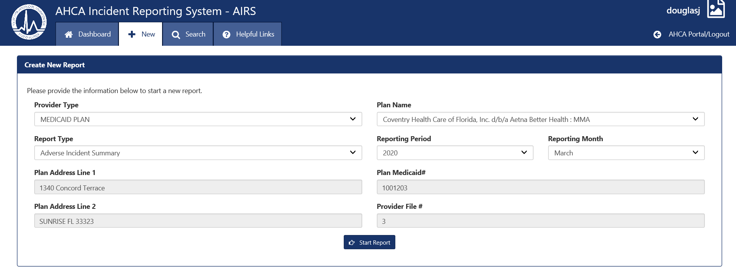

Note: the greyed-in boxes cannot be edited or modified.

Click on the Start Report button at the bottom of this field.



The next screen you see is for the Plan Information. This screen is automatically filled out for you. Click on the next button.

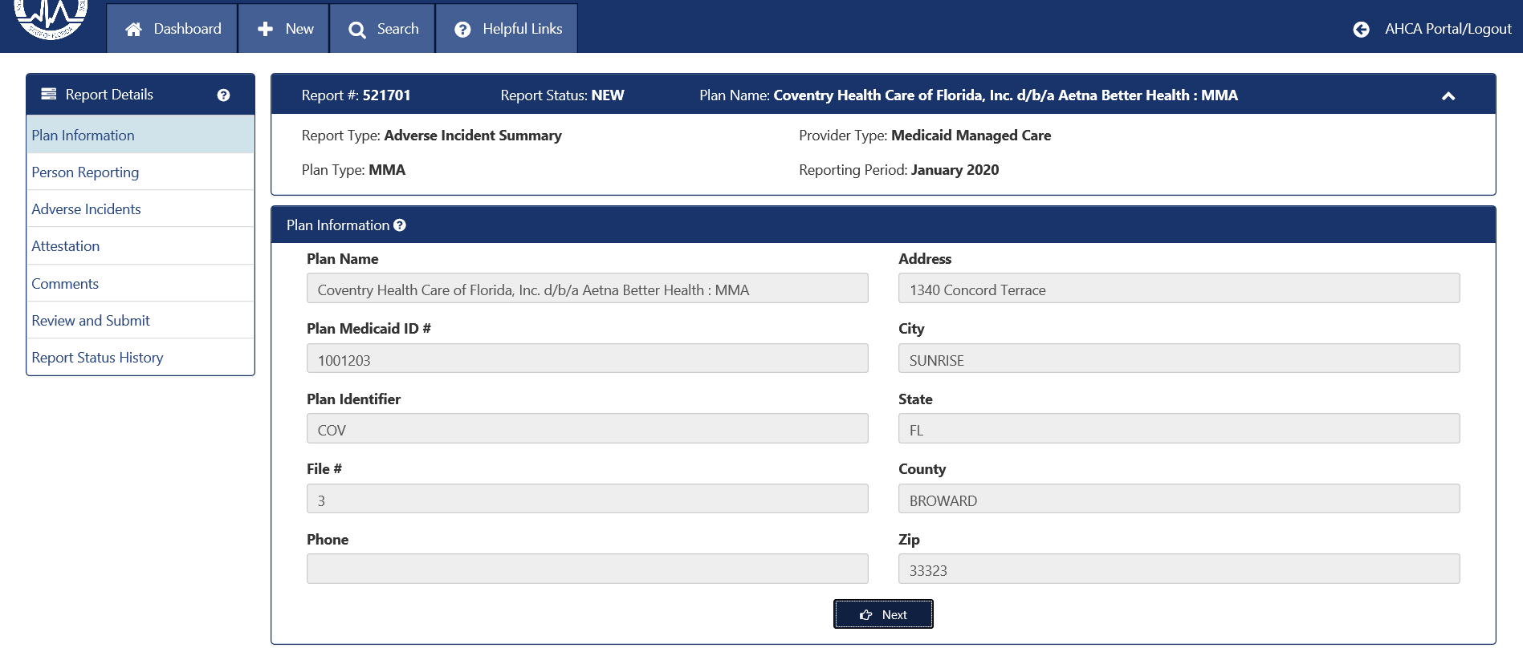

The next screen is for the Person Reporting. The reporter’s name, email, and phone number are automatically filled out, based on your Single Sign On account. These fields are greyed-out and are not editable from AIRS. However, these fields can be edited in the Single Sign On portal.

You will need to select a title from the drop-down menu. If you are a licensed medical professional, choose “licensed staff” as your title, and you will be asked to provide your license number. If you choose “other” from the drop-down, you will be prompted to fill in your title.

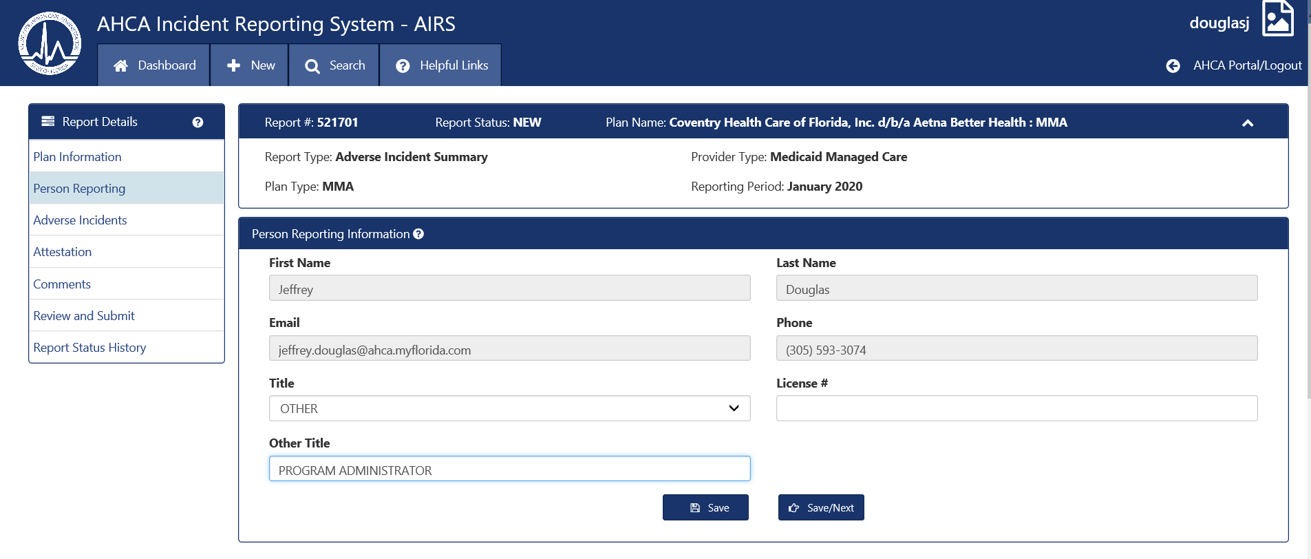

The Person Reporting Screen is the first AIRS screen that the health plans are able to edit. At the bottom, you will see two buttons, Save and Save/Next. Save saves the information on the screen. Save/Next saves the information and takes you to the next screen.

The next screen is for the Adverse Incident Summary information. You will see a grid that is exactly like the Excel spreadsheet you were accustomed to completing for this report.

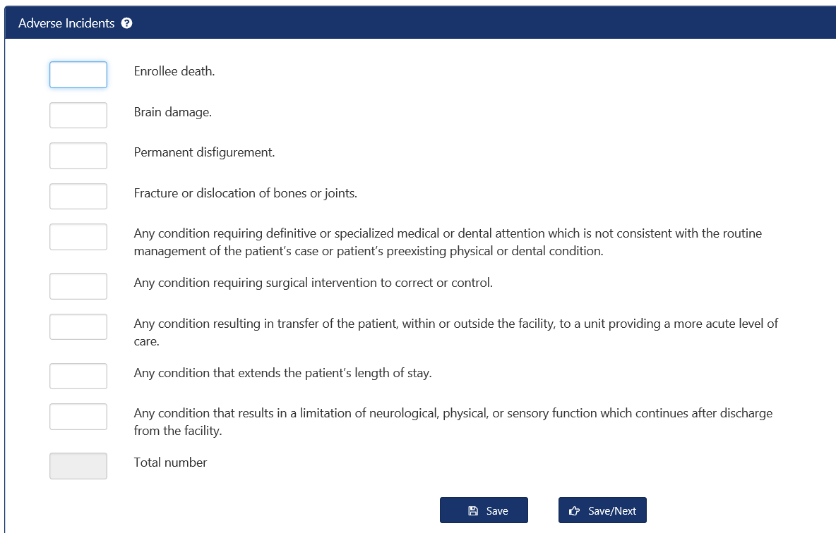

The AIRS user will need to enter the number of each type of incident that occurred during the reporting month. Do not leave fields blank. Enter a Zero if no adverse incidents of that type occurred during the reporting month. The total number of incidents calculates automatically. A sample completed monthly adverse incident screen is provided below.

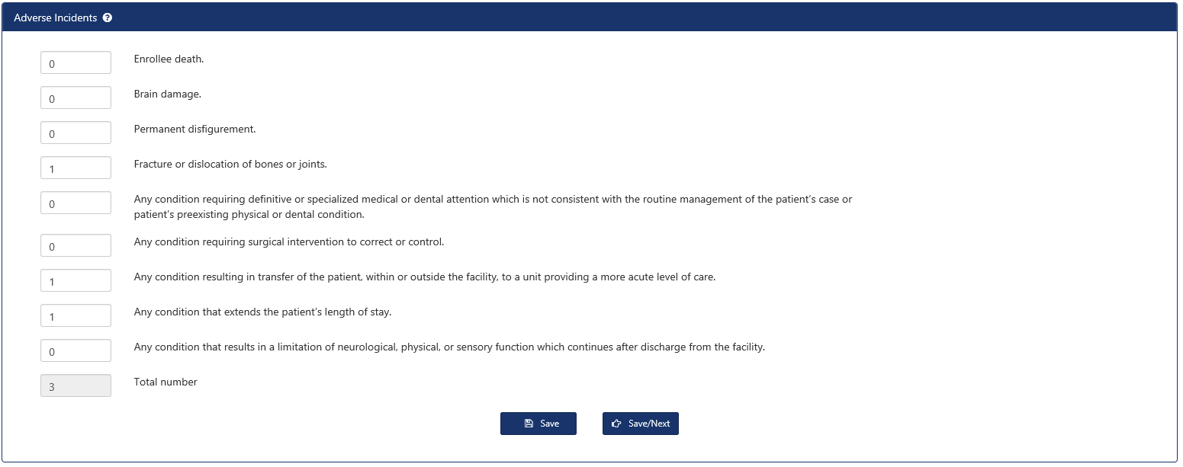

At the bottom, you will see two buttons, Save and Save/Next. Save saves the information on the screen. Save/Next saves the information and takes you to the next screen.

The next screen is for the Attestation. The Adverse Incident Summary Report Attestation is submitted through AIRS as well. You will need to upload your report attestation. The accepted attestation file types are .pdf, .doc, .xls, .ppt, .tif, .txt, .docx, .xlsx and .pptx. Following the upload, a virus scan will run. The virus scan takes approximately 30 seconds to run. During this time, you will see spinning circles as the scan runs.

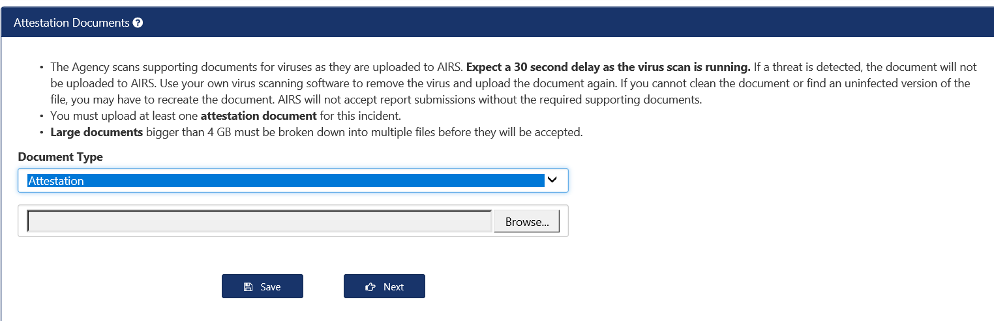

If your attestation was accepted by AIRS, you will see a message saying that your attestation was saved successfully, and you will see the document name and submission status at the bottom of the screen.

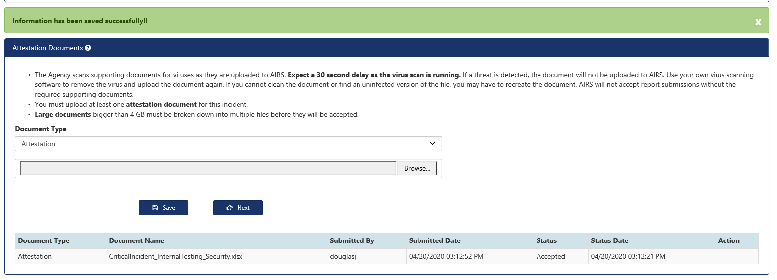

The next screen is for comments. This screen will be blank, unless the Agency has returned your report to you for additional information.

You are now ready to review and submit your monthly adverse incident summary report.

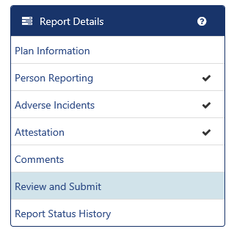

On the left hand side of the AIRS system, you will see a Report Details menu. Please note that there is a checkmark next to Person Reporting, Adverse Incidents, and Attestation. The checkmark indicates that those screens are complete. If there was an incomplete section for any of those reports, you would not see a checkmark.

If there are any reporting errors with your adverse incident summary report, those errors are listed on this screen. In the screenshot below, the Person Reporting the monthly adverse incident summary report has not provided their title. You will also notice that there is not a checkmark next to the Person Reporting screen under the Report Details.

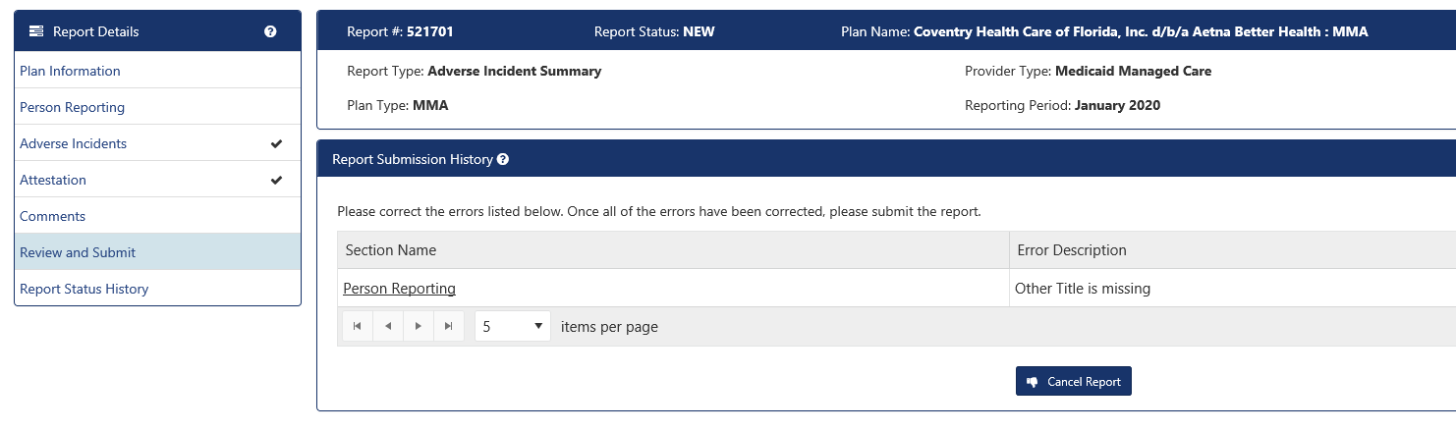

You can go to the screen with the error (in this case, the Person Reporting screen) by either clicking on Person Reporting in the Report Details section, or by clicking on the underlined “Person Reporting” hyperlink in the Report Submission History section.

Once all errors and omissions have been fixed, the section under Report Submission History will be blank and the Submit Report button will appear.

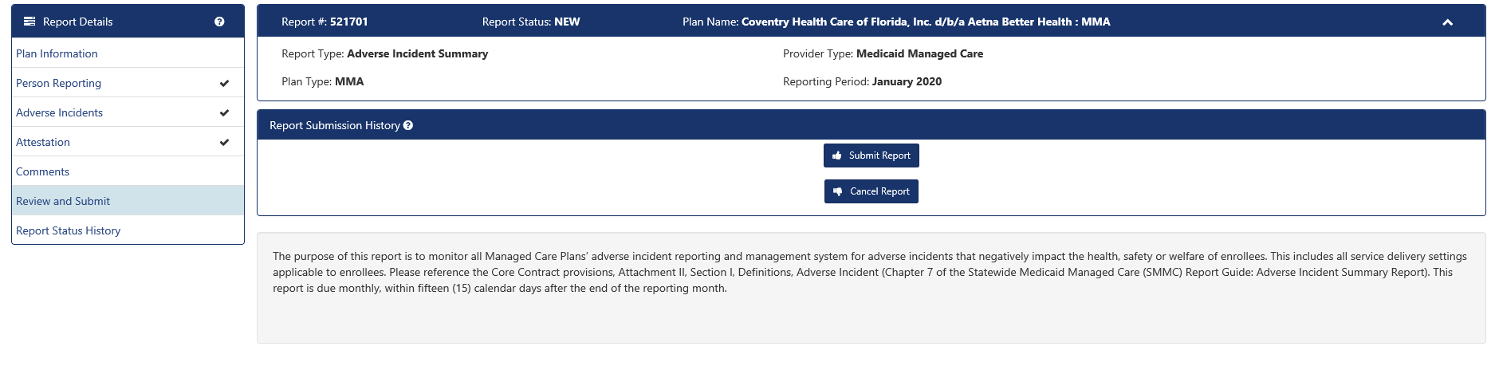

Click on the Submit Report button, and you are finished with your report. Click on the link for the PDF under the Document Name column to view or print a copy of the submitted report.

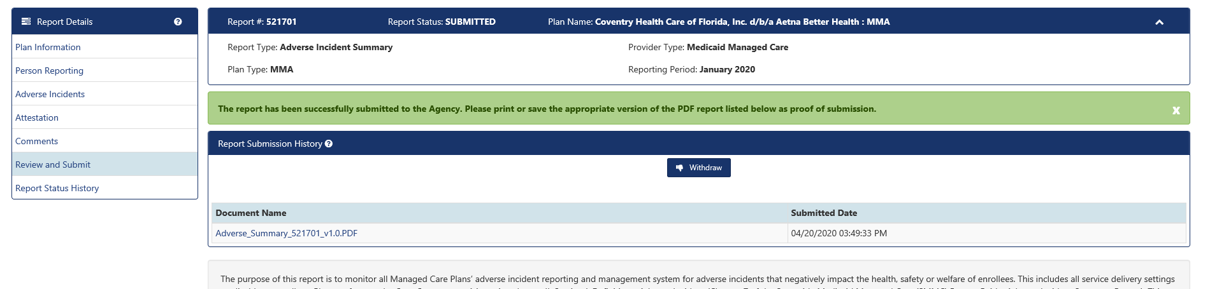

**How to Create the Monthly Adverse and Critical Incident report for Comprehensive and LTC Plus Plans**

All managed care plan adverse and incident reporting begins the same way. From the Dashboard, click on “New”.



**AIRS will bring up a Create New Report screen.**



Provider Type on the Create New Report Screen defaults to Medicaid Plan. This is correct. Do not change this Provider Type.

Select your plan name from the drop down menu. Make sure to choose the LTC plan if you are reporting for a Comprehensive Health Plan.

Next, you will choose the Report Type from the drop-down menu. Since Comprehensive and LTC Plus plans are required to submit the both monthly adverse and critical incident summary reports and individual critical incident reports, you will need to select Critical Incident Summary.

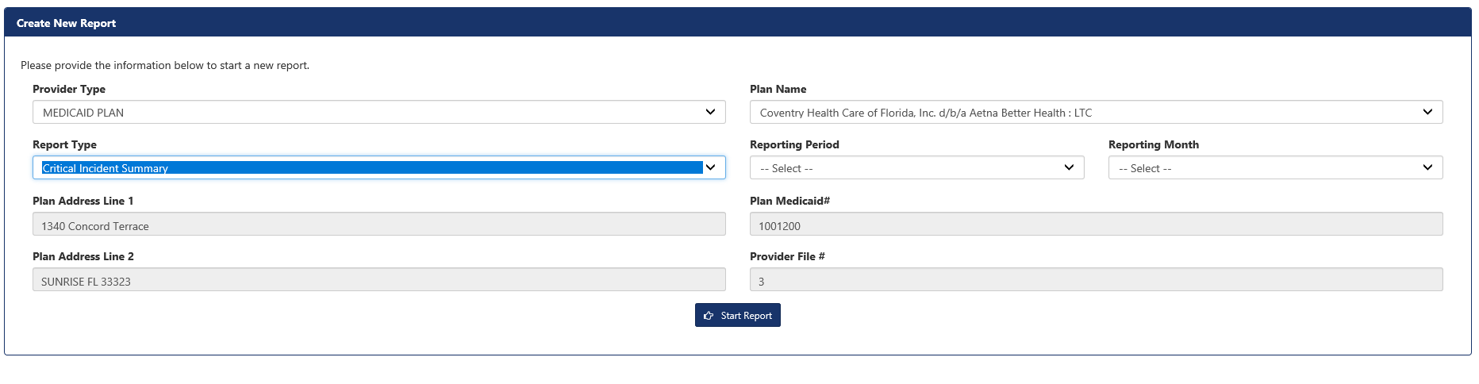

You will next select the reporting period (year) and reporting month from the drop down menu.

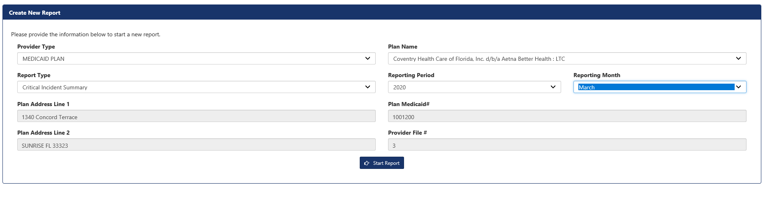

Note: the greyed-in boxes cannot be edited or modified.

Click on the Start Report button at the bottom of this field.

The next screen you see is for the Plan Information. This screen is automatically filled out for you. Click on the next button.

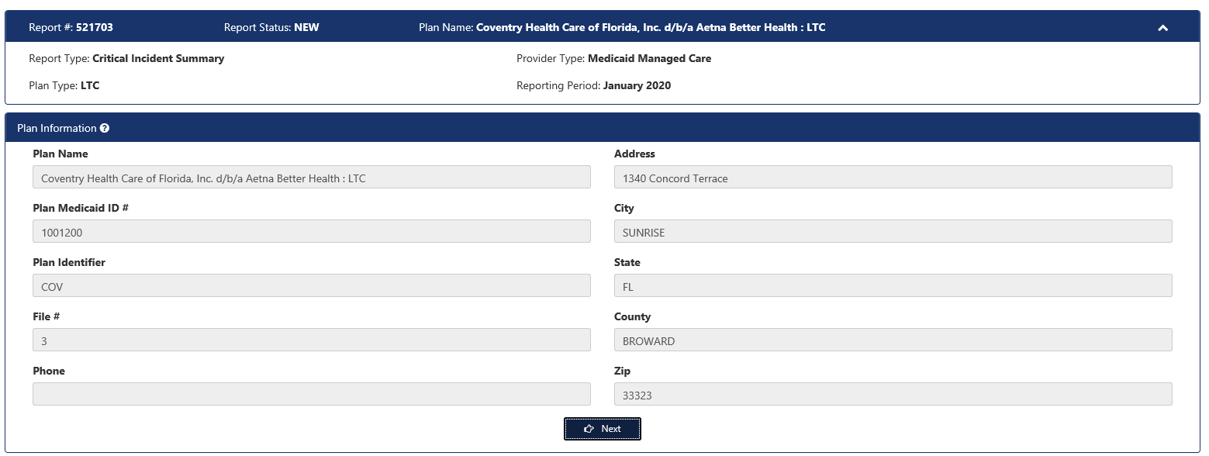

The next screen is for the Person Reporting. The reporter’s name, email, and phone number are automatically filled out, based on your log-on registration. These fields are greyed-out and are not editable.

You will need to select a title from the drop-down menu. If you choose “licensed staff” as your title, you will be asked to provide your license number. If you choose “other” from the drop-down, you will be prompted to fill in your title.

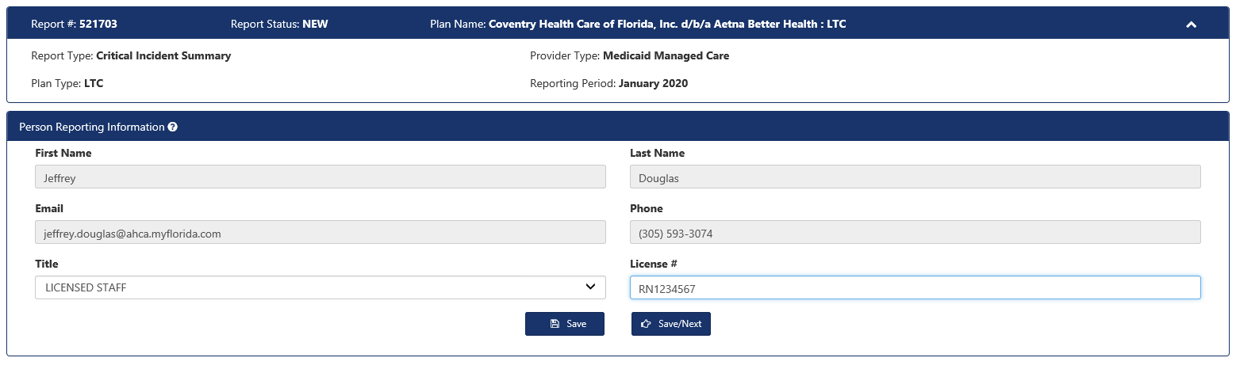

The Person Reporting Screen is the first AIRS screen that the health plans are able to edit. At the bottom, you will see two buttons, Save and Save/Next. Save saves the information on the screen. Save/Next saves the information and takes you to the next screen.

The next screen is for the Critical Incident Summary information. You will see a grid that is exactly like the Excel spreadsheet you were accustomed to completing for this report.

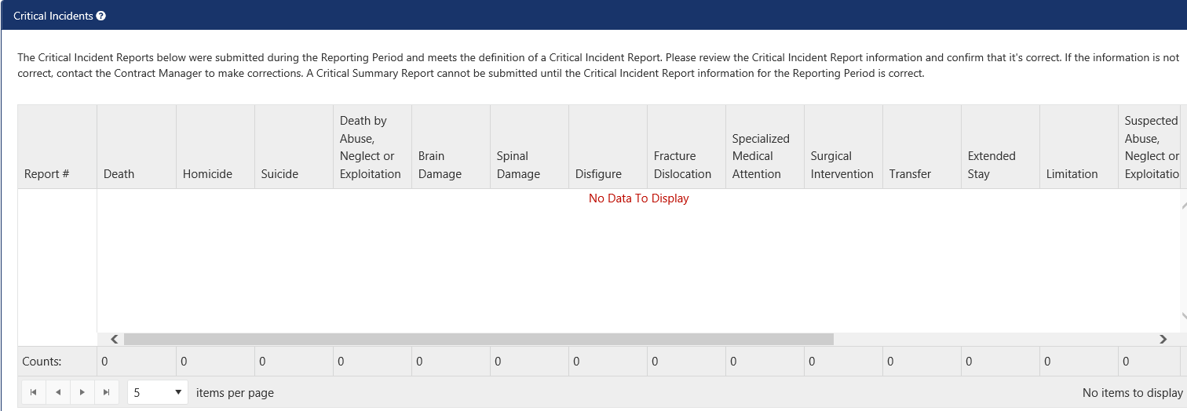

The AIRS system will automatically include the numbers for the reporting month, based off your health plan’s submitted individual critical incidents. The only action that you will need to take on this screen is to confirm that thenumber ofcritical incidents that AIRS calculated for your health plan are correct. To confirm, click in the box next to the confirmation statement, as shown below.

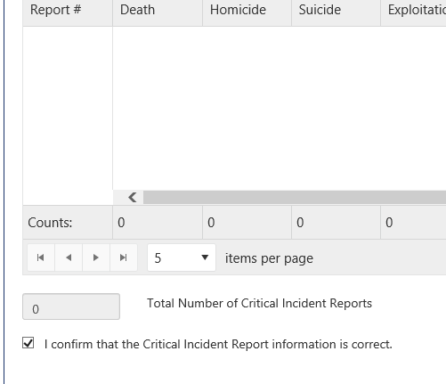

If an incorrect Critical Incident Type was selected on one of the Individual Critical Incident reports, contact your contract manager to have the Individual Critical Incident report re-opened so the Critical Incident Type can be corrected before submitting the Critical Incident Summary report.

At the bottom of the Critical Incidents screen, you will see two buttons, Save and Save/Next. Save saves the information on the screen. Save/Next saves the information and takes you to the next screen. Click on Save/Next.

The next screen is for the Adverse Incident Summary information. You will see a grid that is exactly like the Excel spreadsheet you were accustomed to completing for this report.



The AIRS user will need to enter the number of each type of incident. Do not leave fields blank. Enter a Zero if no adverse incidents of that type occurred during the reporting month. The total number of incidents calculates automatically. A sample completed monthly adverse incident screen is provided below.



At the bottom, you will see two buttons, Save and Save/Next. Save saves the information on the screen. Save/Next saves the information and takes you to the next screen.

The next screen is for the Attestation. The Adverse Incident Summary Report Attestation is submitted through AIRS as well. You will need to upload your report attestation. The accepted attestation file types are .pdf, .doc, .xls, .ppt, .tif, .txt, .docx, .xlsx and .pptx. Following the upload, a virus scan will run. The virus scan takes approximately 30 seconds to run. You will see swirling circles while the scan runs.



If your attestation was accepted by AIRS, you will see a message saying that your attestation was saved successfully, and you will see the document name and submission status at the bottom of the screen.



The next screen is for comments. This screen will be blank, unless the Agency has returned your report to you for additional information. Click on Next to go to the Review and Submit Screen.

You are now ready to review and submit your monthly adverse and critical incident summary report.

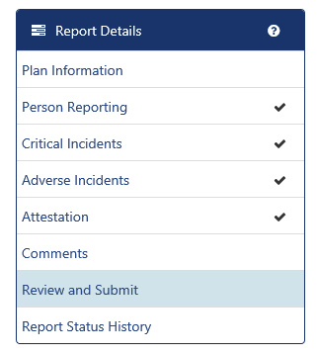

On the left hand side of the AIRS system, you will see a Report Details menu. Please note that there is a checkmark next to Person Reporting, Critical Incidents, Adverse Incidents, and Attestation. The checkmark indicates that those screens are complete. If there was an incomplete section for any of those reports, you would not see a checkmark.

If there are any reporting errors with your adverse and critical incident summary report, those errors are listed in the Report Submission History section of the Review and Submit screen. In the screenshot below, AIRS has detected an error in the adverse incident screen. You will also notice that there is not a checkmark next to the Adverse Incident screen under the Report Details.

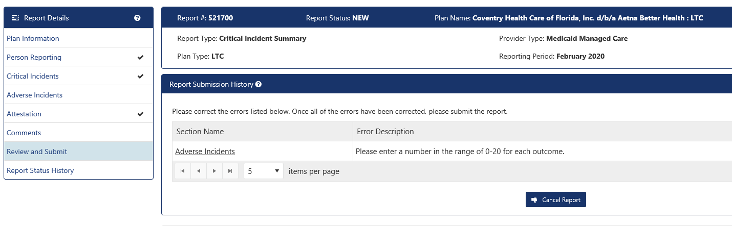

You can go to the screen with the error (in this case, the Adverse Incident screen) by either clicking on Adverse Incidents in the Report Details section, or by clicking on the underlined Adverse Incidents hyperlink in the Report Submission History section.

****Once all errors and omissions have been fixed (or if there was never a mistake), the section under Report Submission History will be blank and the Submit Report button will be visible.

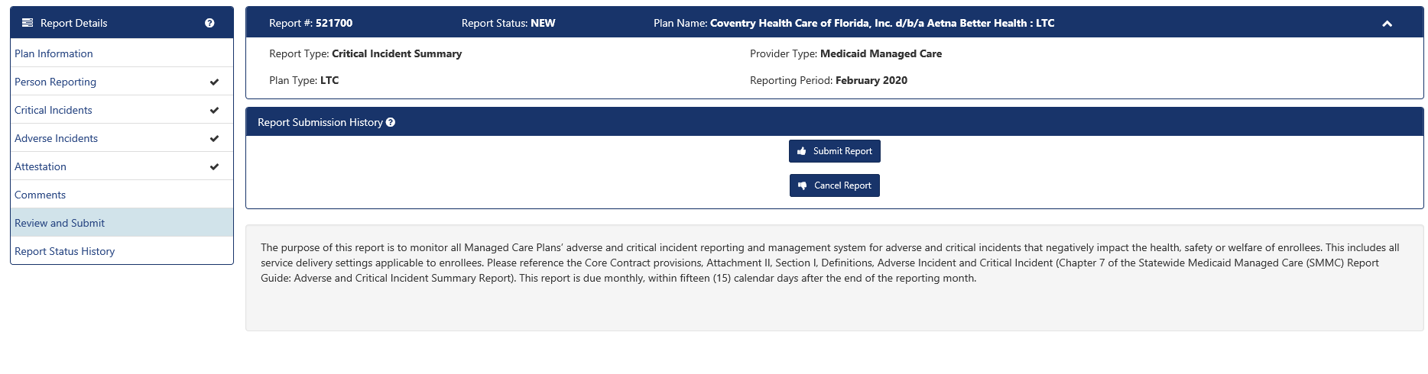

Click on the Submit Report button, and you are finished with your report. You have the option of printing your submitted report if you wish from the PDF file that the AIRS system generated.

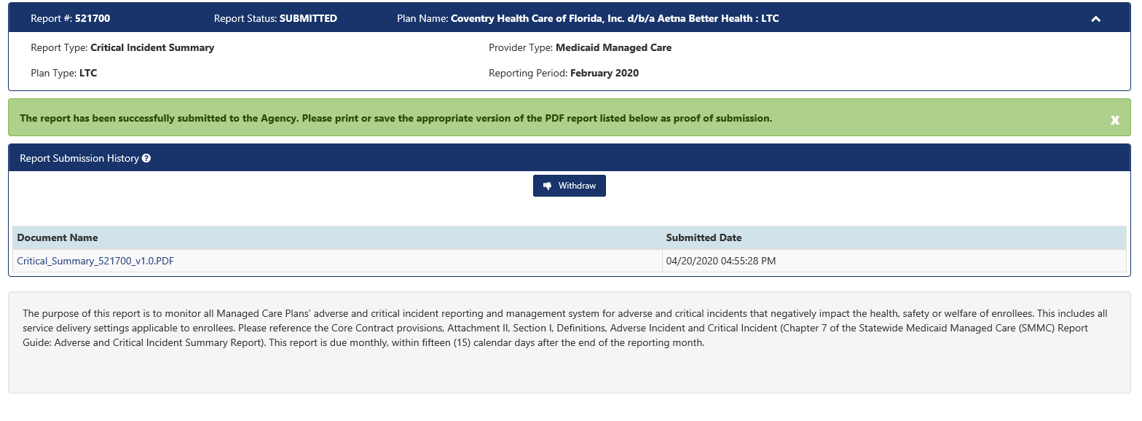

**How to Create the Individual Critical Incident reports for Comprehensive and LTC Plus Plans**

All managed care plan adverse and incident reporting begins the same way. From the Dashboard, click on “New”.



AIRS will bring up a Create New Report screen.



Provider Type on the Create New Report Screen defaults to Medicaid Plan. This is correct. Do not change this Provider Type.

Select your plan name from the drop down menu. Make sure to choose the LTC plan if you are reporting for a Comprehensive Health Plan.

Next, you will choose the Report Type from the drop-down menu. Since Comprehensive and LTC Plus plans are required to submit the both monthly adverse and critical incident summary reports and individual critical incident reports, you will need to select Critical Incident.

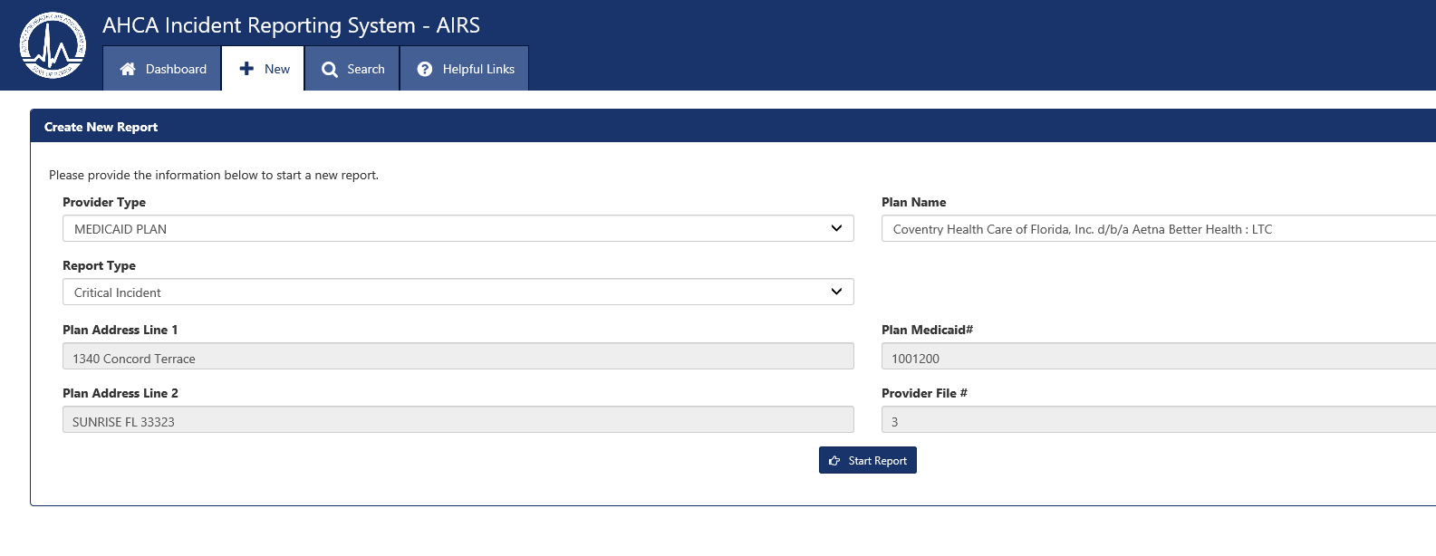

Click on the Start Report button at the bottom of this field.

The next screen you see is for the Plan Information. This screen is automatically filled out for you. Click on the next button.

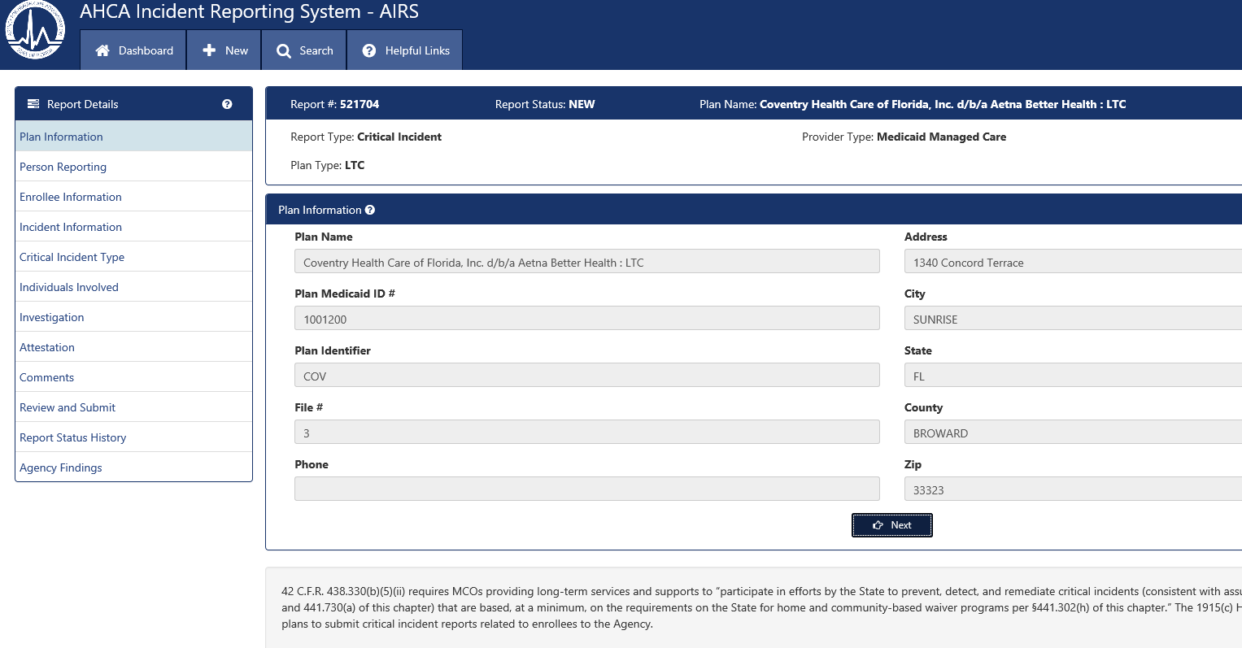

The next screen is for the Person Reporting. The reporter’s name, email, and phone number are automatically filled out, based on your log-on registration. These fields are greyed-out and are not editable.

You will need to select a title from the drop-down menu. If you choose “licensed staff” as your title, you will be asked to provide your license number. If you choose “other” from the drop-down, you will be prompted to fill in your title.

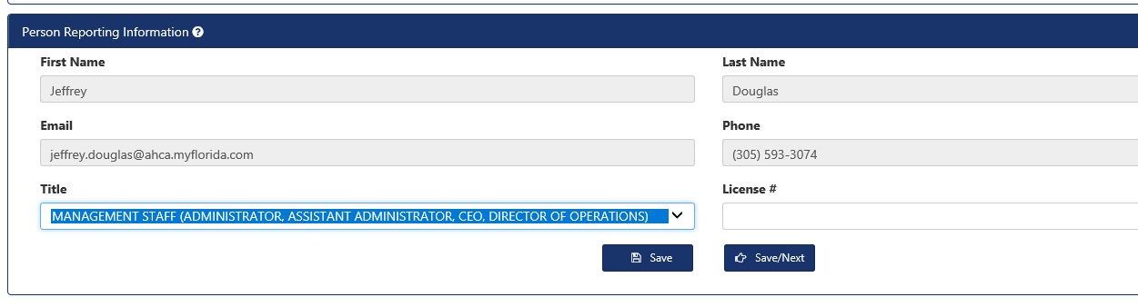

The Person Reporting Screen is the first AIRS screen that the health plans are able to edit. At the bottom, you will see two buttons, Save and Save/Next. Save saves the information on the screen. Save/Next saves the information and takes you to the next screen.

The next screen is for information related to the enrollee involved in the critical incident. You will need to enter the enrollee’s first and last name and 10-digitMedicaid ID number. You will next select the region in which the enrollee lives and the county of residence. A sample completed Enrollee Information screen is provided below.

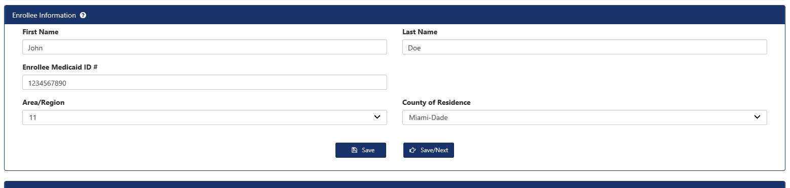

Click on save or save/next to go to the next screen, the Incident Information screen.

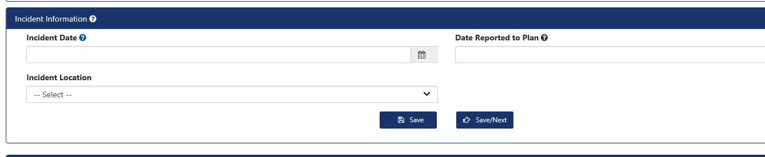

You will need to enter the date that the incident occurred (MM/DD/YYYY) or you can click on the corresponding date from the calendar feature.

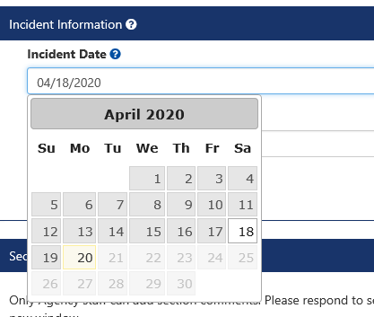

Next, you will need to enter the date that the incident was reported to the health plan (MM/DD/YYYY) or you can click on the corresponding date from the calendar feature.

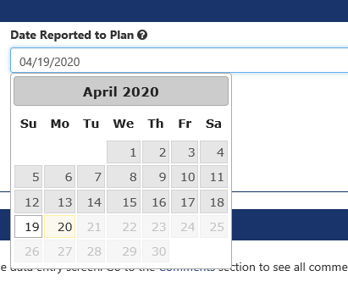

The next field on this screen asks for the incident location. Your choices for incident location are facility, home, transport, or other location (such as elopement). Depending on which location you choose, you will receive additional fields to complete to provide the exact location. For example, in the example below, the incident occurred at the enrollee’s home, so fields are displayed to capture the enrollee’s home address.

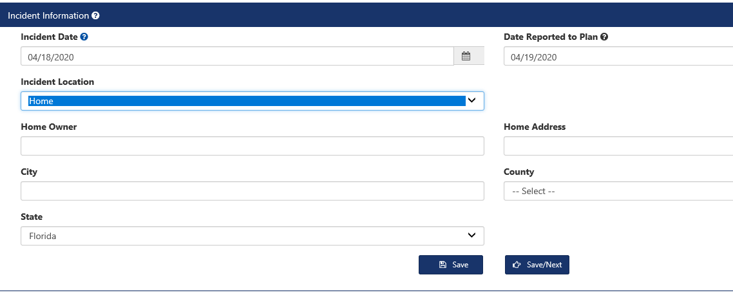

As an example, we will say the incident occurred while the enrollee was being transported to her doctor’s office. After selecting transport as the incident location, AIRS will have you provide the transportation vendor’s name, the street address and city where the incident occurred. The completed AIRS Incident information screen for reporting this incident will look like the screenshot below.

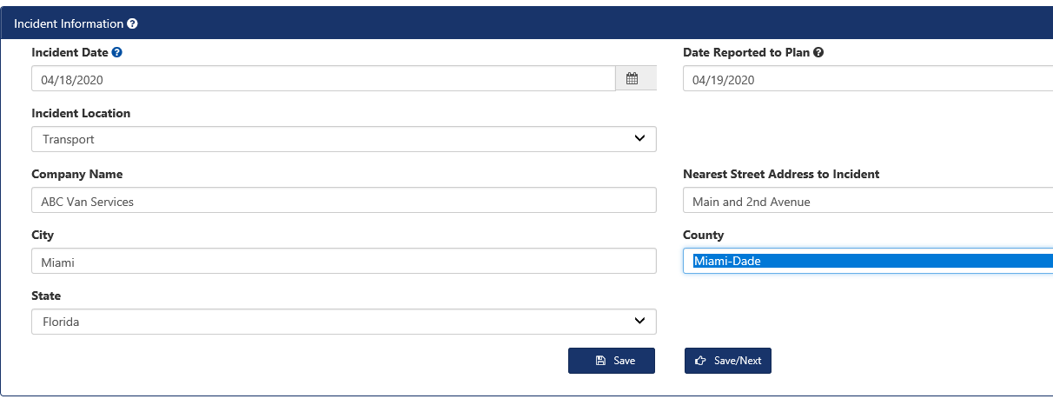

Once all fields, including pop-up fields for the Incident Information have been completed, click on save or save/next to go to the next screen, the Critical Incident Type screen.

The Critical Incident Type screen should look familiar to users who have previously completed an Individual Critical Incident Report. On this screen, the LTC health plan will check the one best descriptor of the type of Critical Incident that is being reported. To check the incident type, click in the box next to the descriptor.

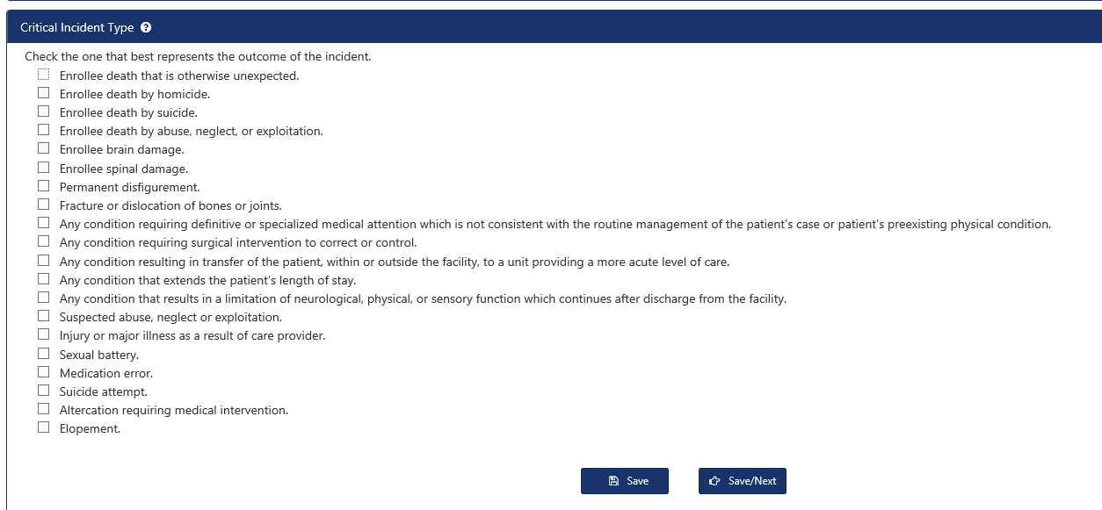

In the example below, the health plan is indicating the individual critical incident involves Suspected abuse, neglect or exploitation.

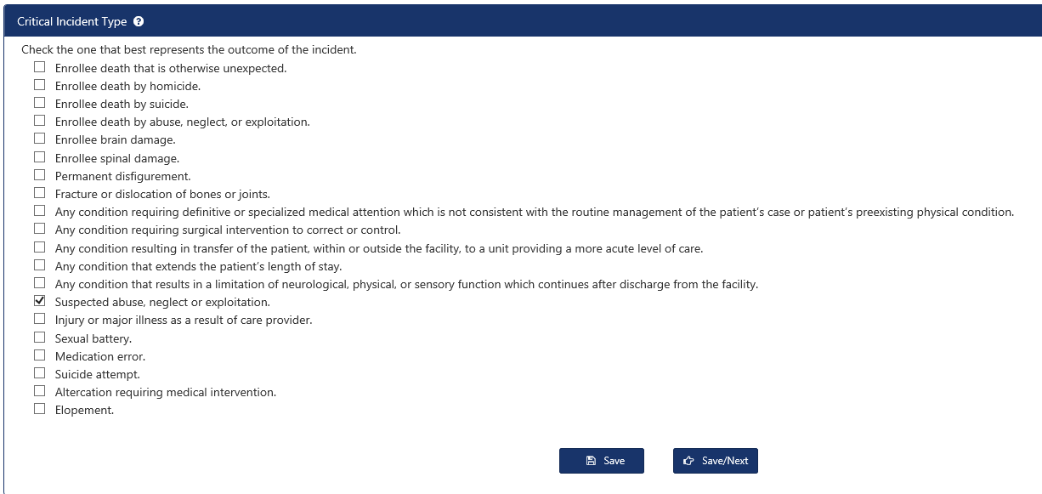

Once the type of critical incident is selected, click on save or save/next to go to the next screen, the Individuals Involved screen.

#### The Individuals Involved screen is where the LTC plan identifies all HCBS personnel and witnesses that contacted the enrollee during or after the incident. The enrollee does not need to be re-identified in this section.

#### 

#### For example, let’s say the health plan is completing a critical incident in which the enrollee was slapped on the face by his home health aide, Jane Doe. The incident was witnessed by the enrollee’s spouse, Mary Smith. The health plan would need to include information on both Ms. Doe and Ms. Smith on this screen.

#### To start, click on Add Individual, which will bring up new fields for entry.

#### 

#### The completed “Add Individual” field for Ms. Doe might look like this. Please note that although SSN# is a listed field for individuals involved, it is not a required field.

#### 

#### Click Save.

#### Now, you will need to click on “Add Individual” again to provide information about the witness to this event, the enrollee’s spouse.

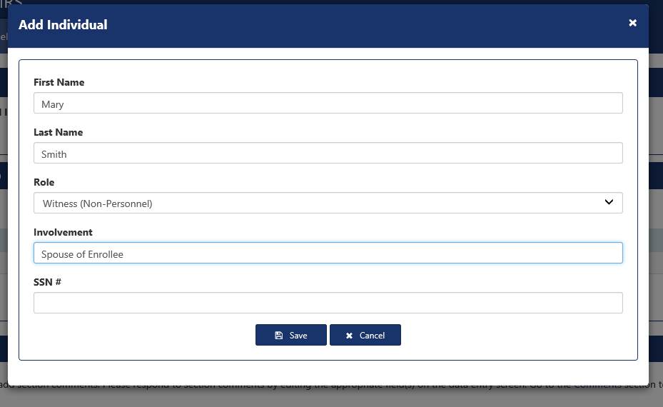

This process would be repeated until information about all personnel and parties involved with the incident have been inputted into AIRS.

For our example, the completed Individuals Involved screen looks like this:

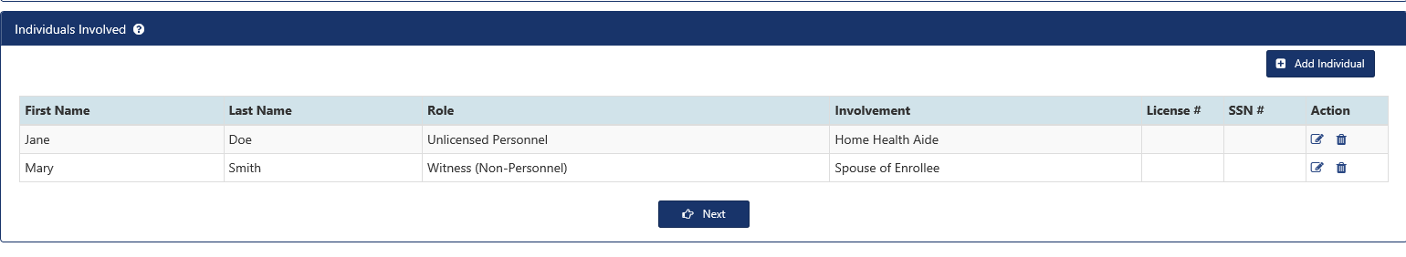

Please note on the right hand side of the Individuals Involved screen, there are two icons under the word Action. If you click on the pen and paper icon, you can edit information about the Individuals Involved. If you click on the garbage can, you can delete the Individual Involved.

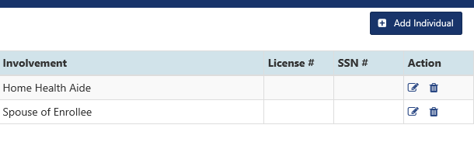

When you have completed adding information for all Individuals Involved, click Next to go to the Investigations Screen.

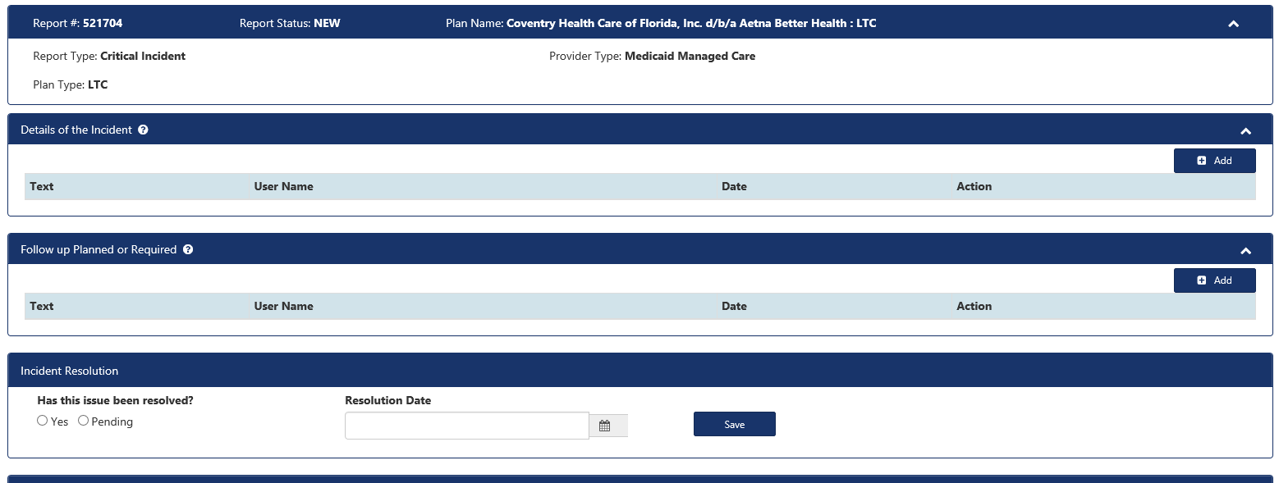

The first field on the Investigations page for you to complete is for the Details of the Incident. To complete this field, click on Add.

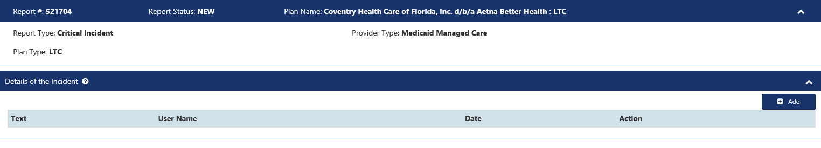

Doing so will bring up a free form field for you to add details of the incident. Include the enrollee’s current diagnosis/diagnoses (ICD-10 codes not required), current medication [if applicable], all reported details about the event, including HCBS service-type and frequency being provided at time of incident, action taken by plan or provider, and any other pertinent information, including current status of enrollee).

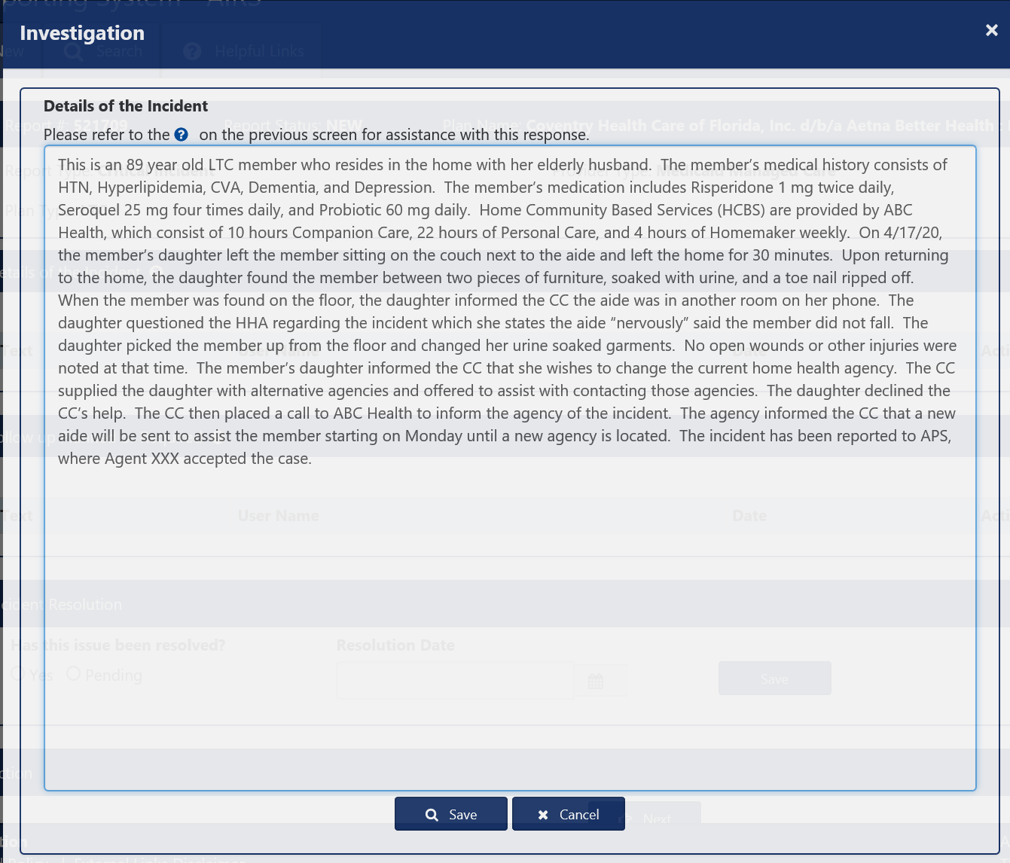

Once you are done with writing up the details of the Incident, click save.

The next field is for Follow-up Planned or Required. To start, click Add.

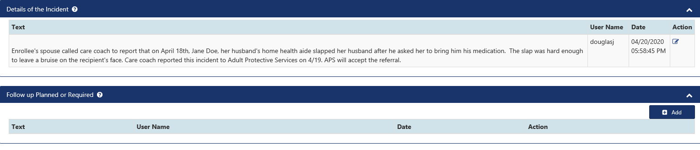

Doing so will bring up a free form field for you to add details of the Planned or Required Follow-Up.

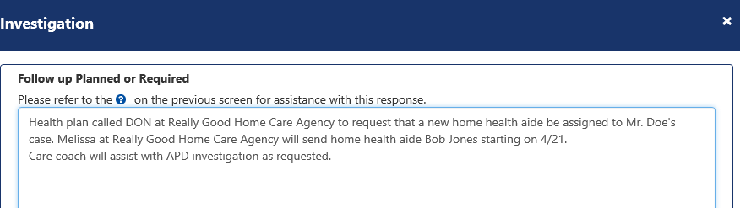

The last item on the Investigations screen is for the health plan to indicate if the incident has been resolved, or if it is still pending. If the incident is resolved, you will need to input a resolution date. In the example below, we have indicated the incident resolution is still pending, so the resolution date box is greyed out.

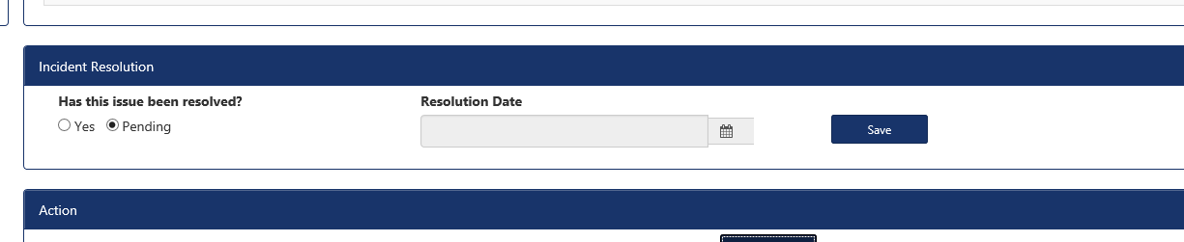

Once all required fields on the investigation screen have been completed, click on save or save/next to go to the next screen, the Comments screen.

The comments screen is blank during the completion of a new individual report. Only Agency staff can add comments. The screen is used by Agency staff to input questions to the health plan about an incident that needs clarifying information. We will discuss the comments screen in detail in the section for “needs info”.

Click on “next” to go to the next screen, the Review and Submit screen.

The review and submit screen allows users to validate their critical incident report submission. If the user has omitted any required elements to the critical incident, a grid in the Report Submission History box will appear showing those elements. In the example below, the AIRS user has not attached the report attestation. You will notice that AIRS identifies the report section with the error and identifies the actual error. You will also notice that the report section name is underlined. This is a hyperlink and clicking on it will take you to the report screen that contains the error.

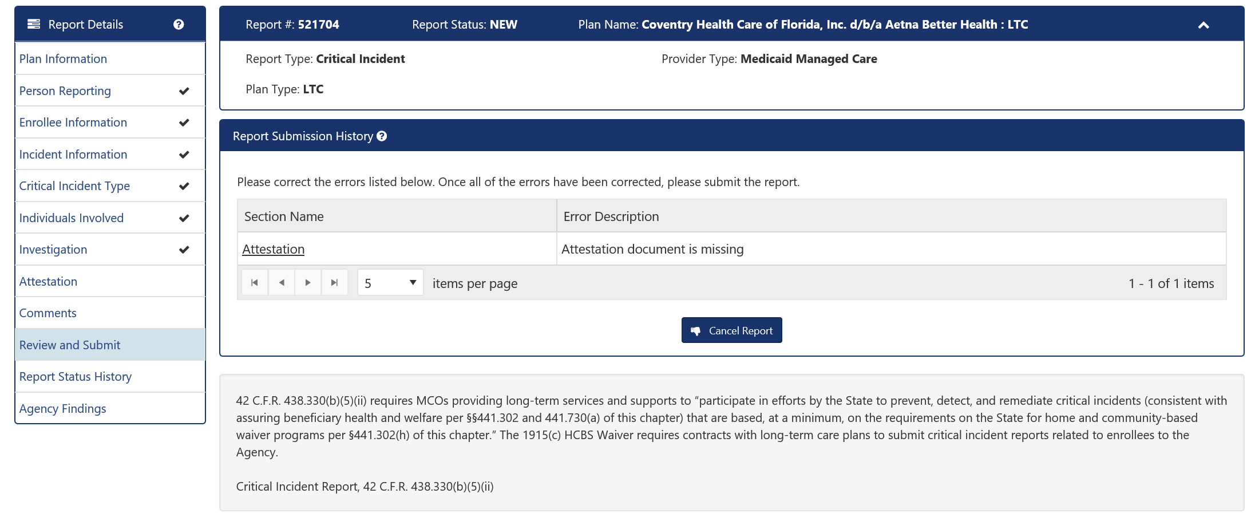

Once all errors have been corrected, the validation box on the Review and Submit screen will be empty and a new button for submitting the critical incident report appears.

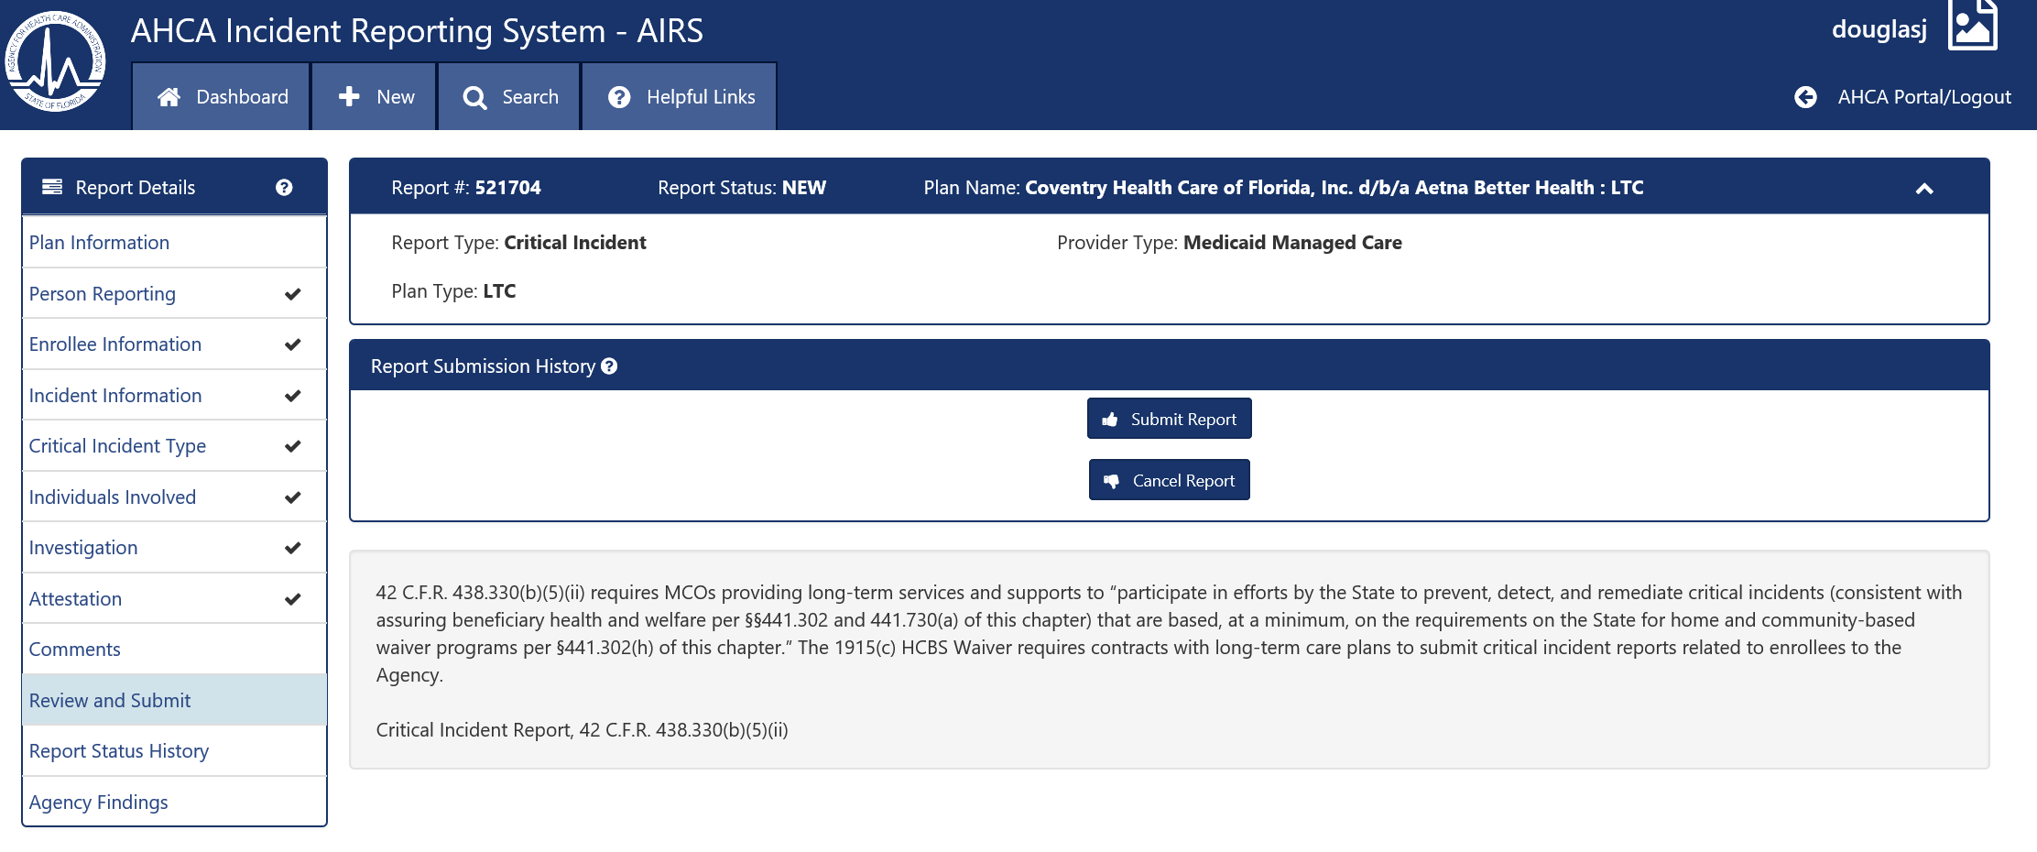

Click on submit report to send your individual critical incident report to the Agency. A notification will appear on this screen notifying you that the report was successfully submitted. The Report Submission History will show a PDF document which is the actual individual critical incident report. You may download or print this report if you wish

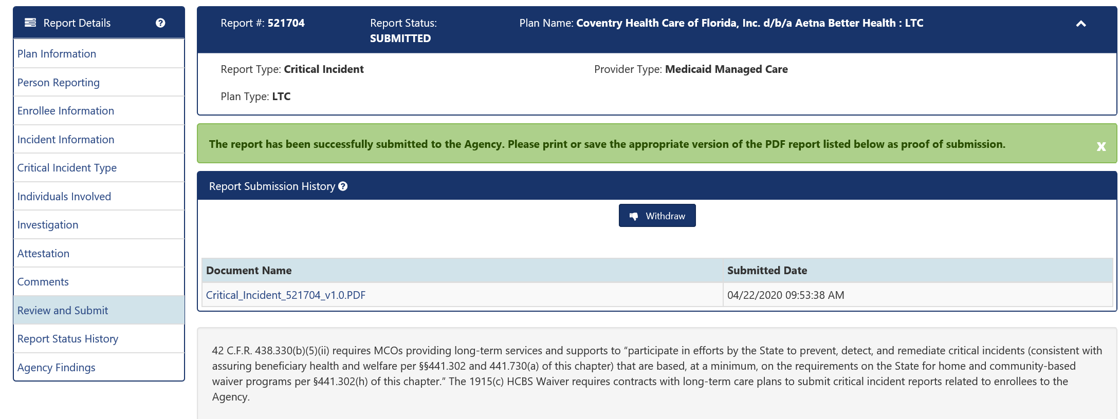

The Report Status History screen is informational only. It will show each time the report status changed as the report moved through the workflow.

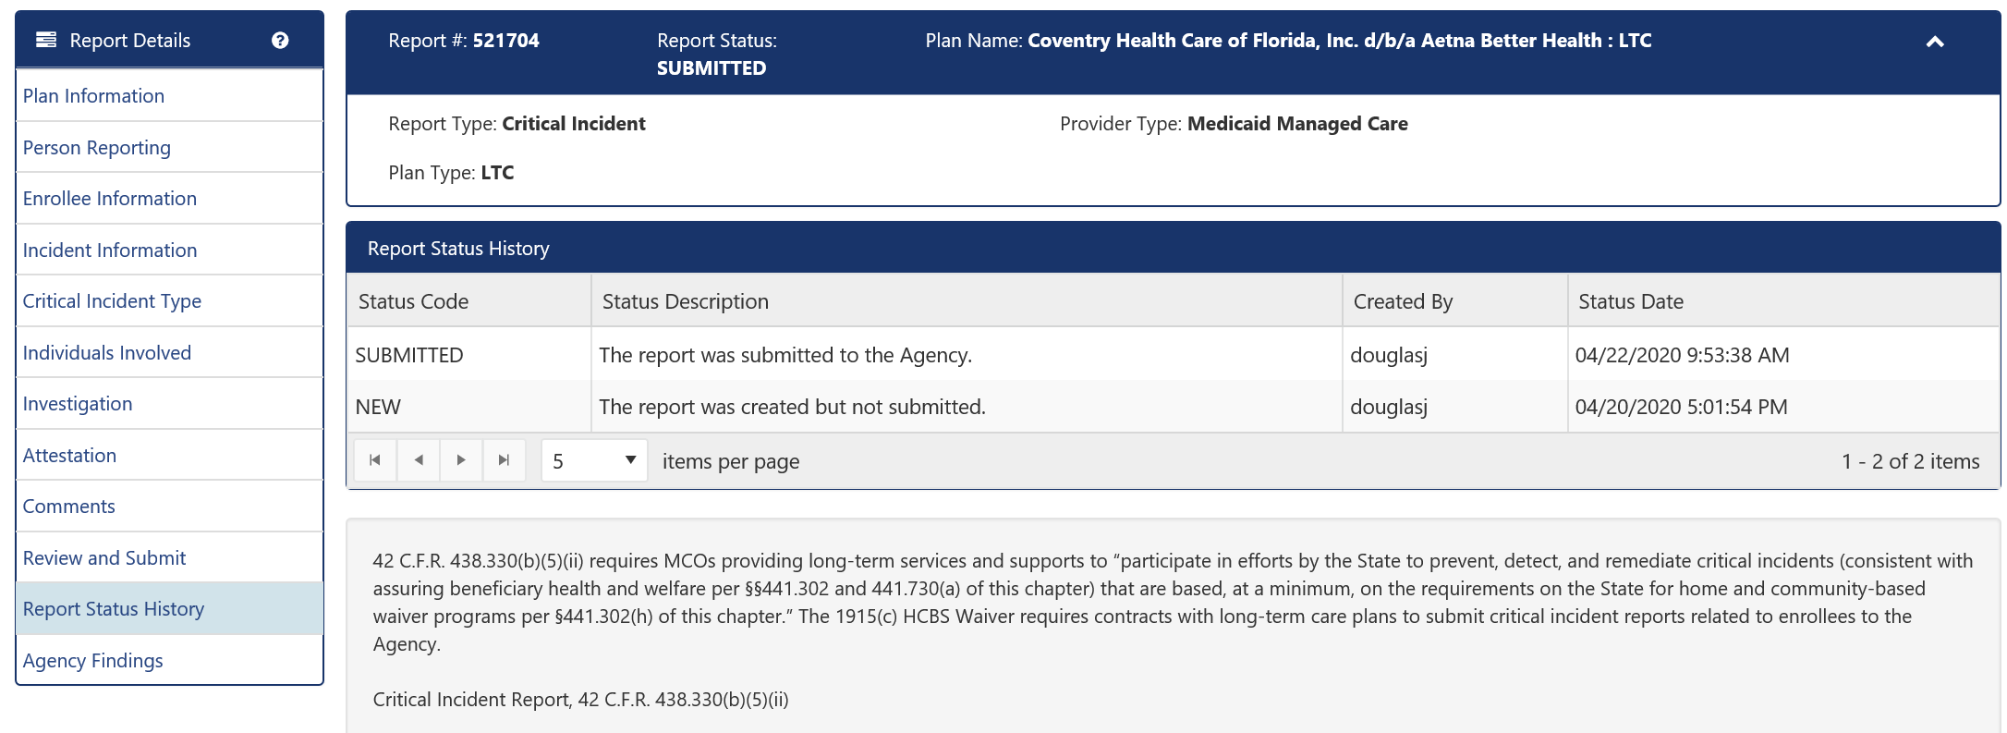

The last screen is for Agency Findings. This screen will be completed by the Agency prior to closing the critical incident. We will discuss the screen in depth in the next section.

**What to do if the Agency Returns Your Report for Additional Information**

There may be times that the Agency returns your report because they have questions, or they need additional information. If this occurs, the health plan will receive an email generated by AIRS that the report has been returned to the plan for modification. Please note the email contains the report number that was returned, to assist in retrieval. However, the health plan cannot access AIRS from the email. Instead, plan staff will need to log into AIRS via the SSO to review the returned critical incident.

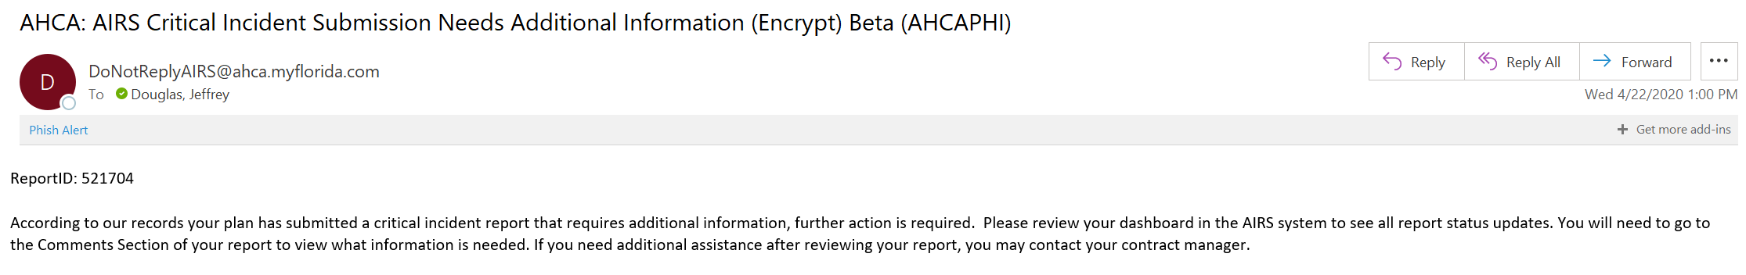

The returned report will appear on the health plan’s AIRS Dashboard in the section labeled “Needs Attention”.

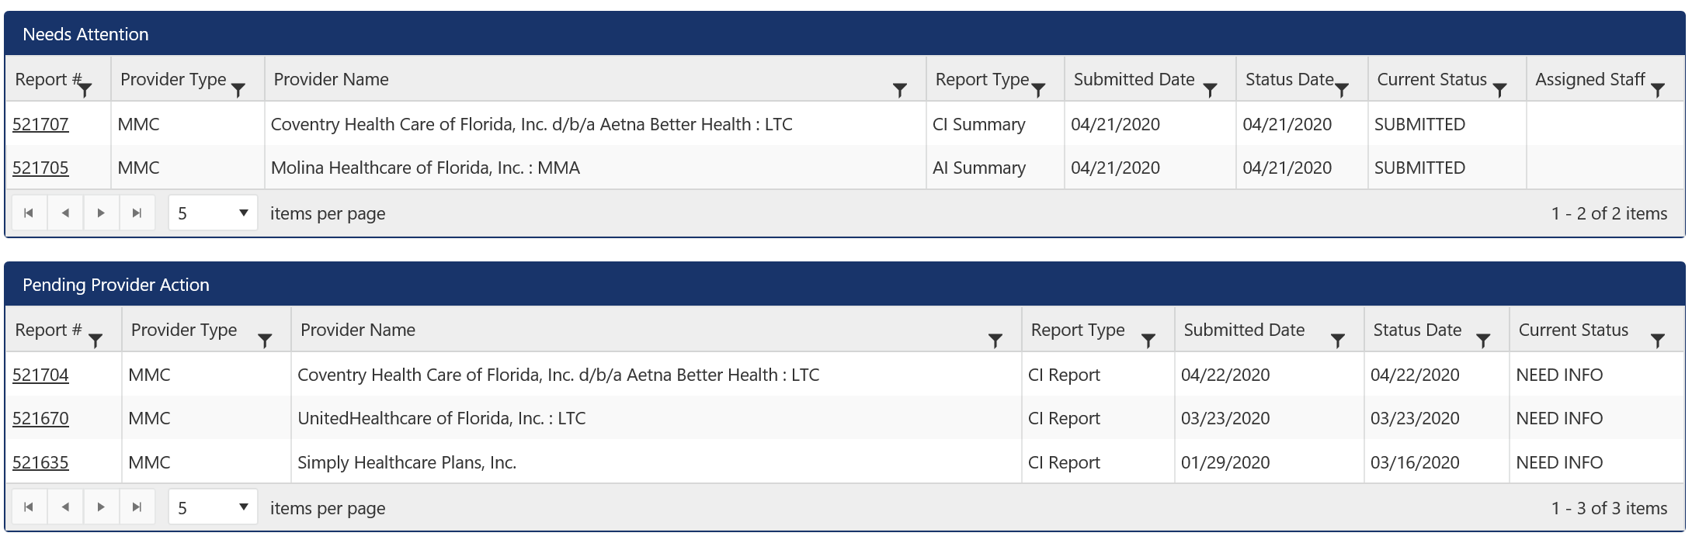

If your click on the report number link (which is underlined), the report will open. Click on the Comments button in the “Report Details” to go to the comments screen to view the Agency’s questions. In the example below, you will notice that the Agency has questions about the Incident Investigation. The health plan can go into the Investigations screen to edit the incident report to answer these questions. On the Investigations screen, a new button has appeared labeled “Add”. Click on this button and a new blank page will appear to add more commentary.

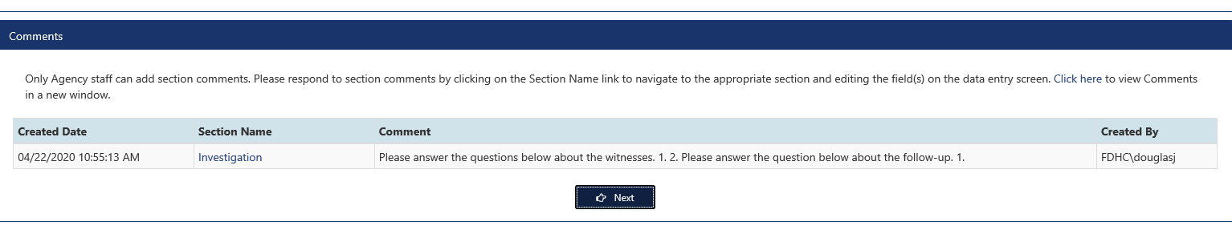

After you finished adding your comments, click save. You new addition will appear on the investigations page above your initial comment.

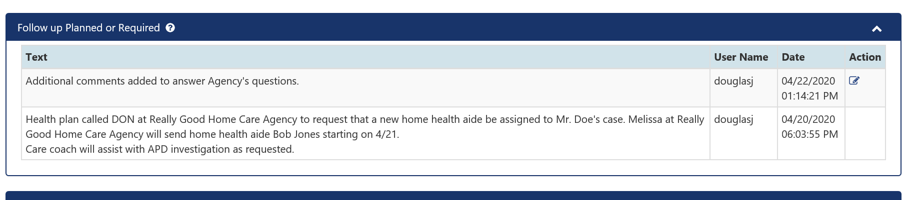

Once the health page has made all of its edits to the returned report, you will go to the Review and Submit screen, revalidate to make sure every field is completed, and then click Submit report.

**When the Agency Has completed its review**

After the Agency has completed its review of the report, they will close the report. AIRS will generate an email to the health plan alerting the plan that the Agency’s findings are available for review. The email will contain the report ID number. The health plan cannot access AIRS from the email. Instead, plan staff will need to log into AIRS via the SSO to review the completed critical incident and Agency Findings.

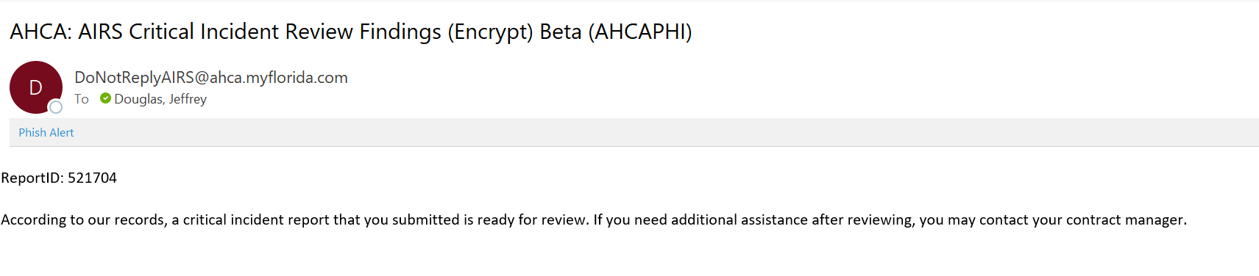

Log into AIRS to see your findings. Closed reports do not appear on your Dashboard. You will need to use the Search feature to pull up your report. From your Dashboard, click on the Search button from the main menu. Enter your report ID number into the appropriate field and click Search. Your report should appear in the Search Results box. Click on the underlined report number link to bring up the report.

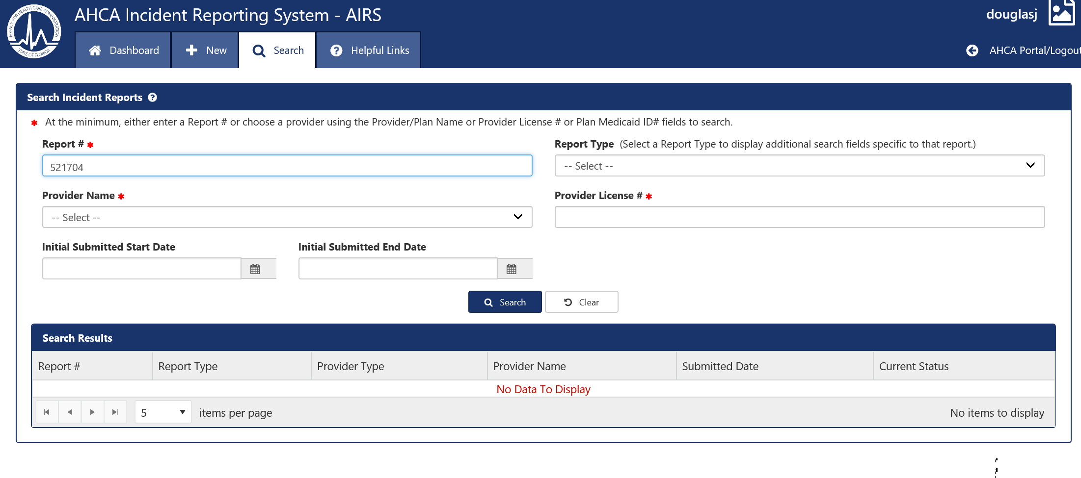

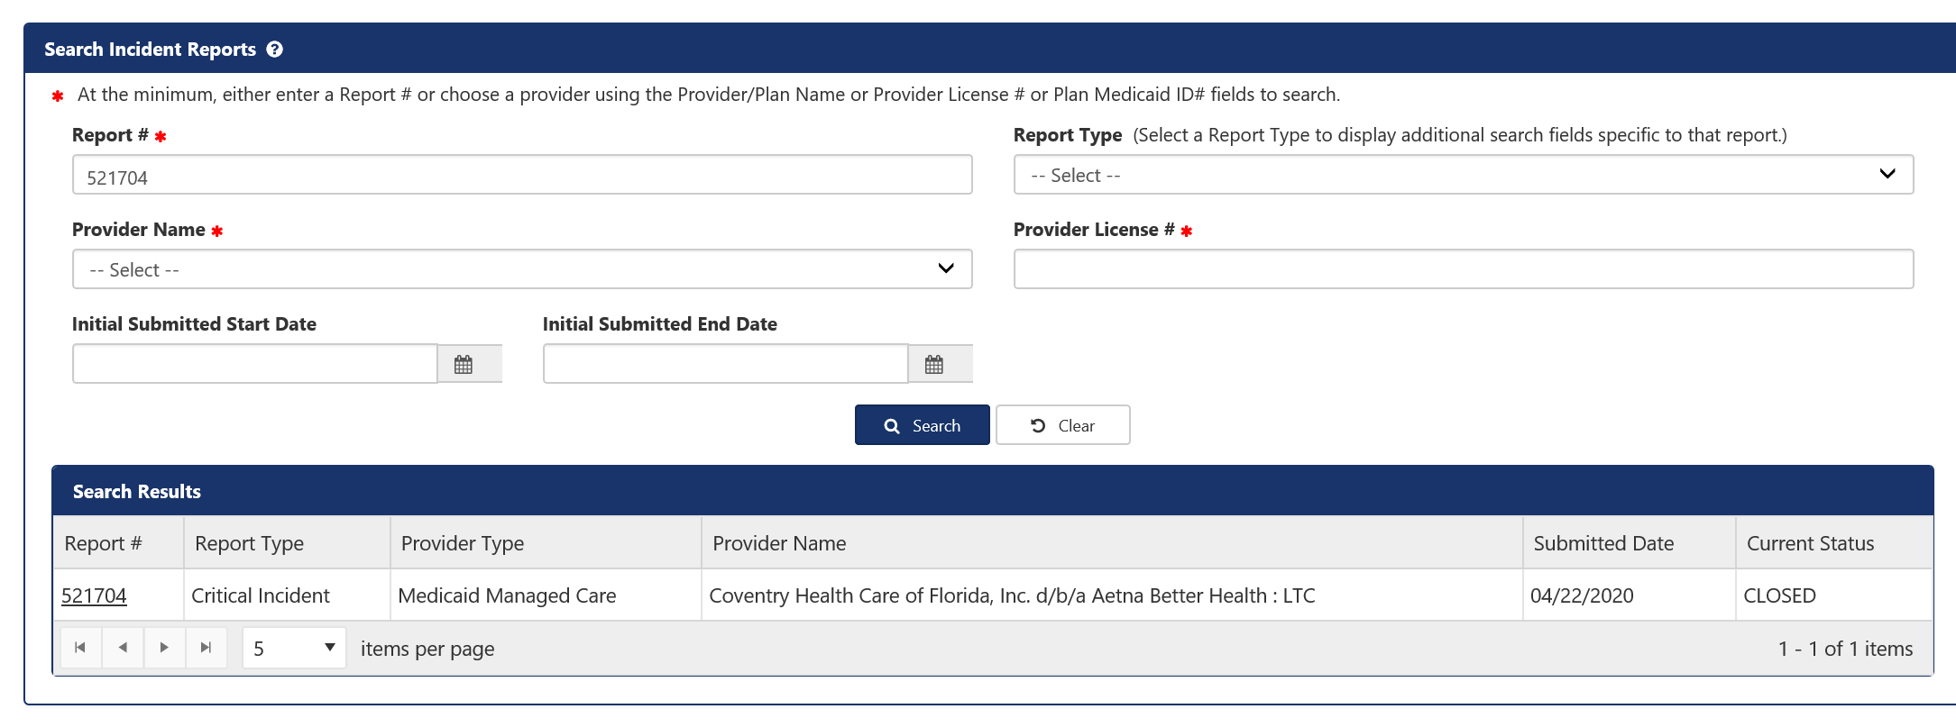

After pulling up your closed report, click on the Agency Findings link inside the Report Details box. This screen will show the Agency’s review/results and contain a PDF link for the critical incident review summary.

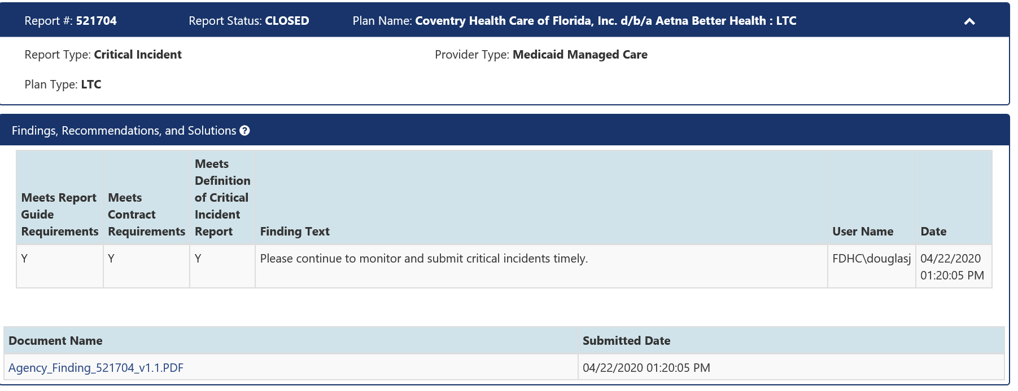

**How to Cancel a Report**

If you begin a report in AIRS, such as an individual critical incident report, and then decide that you should not be reporting that incident to the Agency, you need to cancel the report.

Only reports that have not been submitted can be cancelled. If a report created in error was submitted, then you’ll need to contact your contract manager to ask that the report status be set to NEED INFO so the report can be withdrawn.

To cancel a report, click on the Review and Submit button in the Report Details box. When the Review and Submit screen opens, you will find a Cancel Report button inside the Report Submission History box. Click on that button to cancel your report.

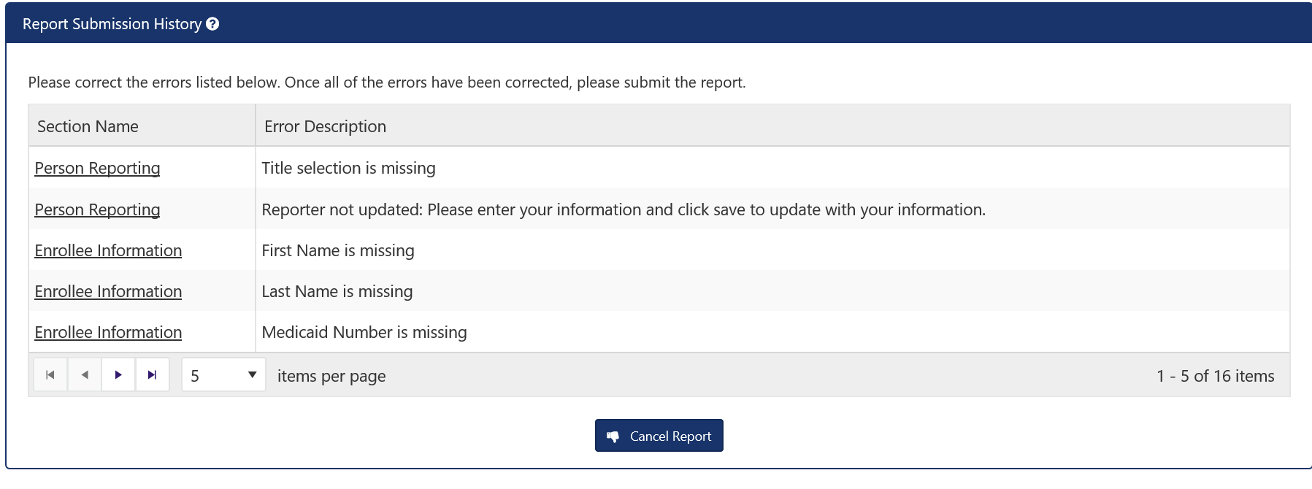

**Troubleshooting**

Forgot username---see page 5

Forgot password---see page 6

Need assistance with Single Sign-On---contact your AHCA contract manager

Need technical assistance related to completing reports in AIRS---contact Terry Boylen ([Terry.Boylen@ahca.myflorida.com](mailto:Terry.Boylen@ahca.myflorida.com) and copy your contract manager

AIRS system not operational---contact your AHCA contract manager

Have questions about how to complete a report with AIRS---contact Medicaid Quality and/or your contract manager